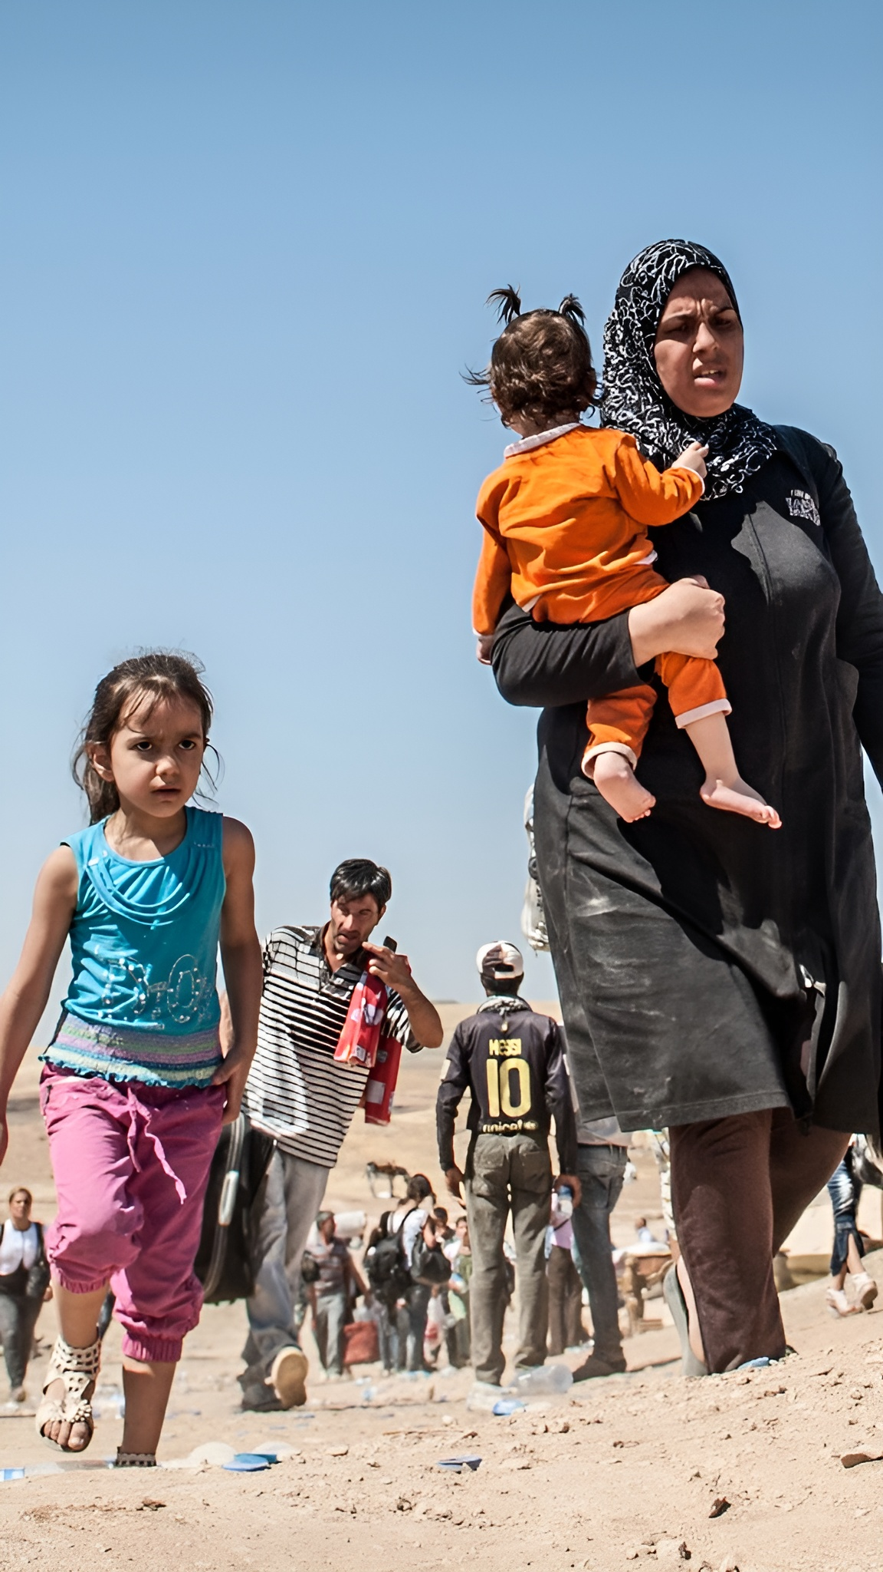
Research Report

SOCHUM

The Question of protecting the Human Rights of Refugees and Displaced People


Summary
The issue of protecting the human rights of refugees and displaced people is one of the most pressing humanitarian challenges of the 21st century. As of April 2025, over 122 million people were forcibly displaced worldwide, including refugees, asylum seekers, internally displaced persons (IDPs), returnees, and stateless persons. Wars in Sudan, Ukraine, Myanmar, and elsewhere have driven these numbers to record highs, while humanitarian funding has dropped to 2015 levels, leaving enormous protection gaps.
The Universal Declaration of Human Rights (Article 14), the 1951 Refugee Convention and its 1967 Protocol, and regional frameworks such as the Cartagena Declaration (1984) provide the foundation for refugee protection. Despite these instruments, violations continue: refugees face arbitrary detention, refoulement, and inadequate humanitarian support. Children and women remain disproportionately affected, with almost 49 million children displaced by conflict and violence worldwide.
Past UN efforts such as the establishment of the UNHCR (1950), the Global Compact on Refugees (2018), and consistent SOCHUM resolutions – have laid important groundwork. However, the gap between international law and state practice remains wide. Protecting refugee rights requires renewed multilateral cooperation, accountability mechanisms, and sustainable funding to ensure displaced people are treated with dignity and fairness.

Background Information
Refugees and displaced people represent one of the most vulnerable groups in the international system. Their forced displacement results from conflict, persecution, human rights abuses, environmental disasters, and increasingly, the effects of climate change. By late 2024, the UNHCR Global Report recorded 129.9 million people of concern, highlighting the scale of the crisis.
The cornerstone of refugee protection is the 1951 Convention relating to the Status of Refugees and its 1967 Protocol, which enshrine principles such as non-refoulement (the prohibition of returning refugees to danger) and the right to asylum. These instruments are complemented by regional agreements like the Cartagena Declaration (1984) in Latin America and the OAU Convention (1969) in Africa.
Despite this legal framework, violations persist. For example, the UN Human Rights Committee ruled that Australia violated refugees’ rights by detaining asylum-seeking children in Nauru, while another UN body found the U.S. and UAE responsible for arbitrarily detaining Afghan refugees. Such cases underscore the challenges of ensuring state compliance.
A critical obstacle is funding. Humanitarian needs have outpaced resources: UNHCR’s programmed requirements for 2024 stood at $10.7 billion, yet only $4.9 billion was spent, leaving a 52% funding gap. This shortfall has reduced protection services, education access, and healthcare for displaced populations.
Children represent the face of displacement. By 2024, 48.8 million children were displaced, with nearly 20 million living as refugees or asylum seekers. These children face unique threats, including lack of education, child labour, and trafficking. Women also remain at risk, with reports of sexual exploitation by aid workers and security forces in Chad highlighting the dangers of weak accountability.
SOCHUM has historically debated this issue through resolutions addressing the protection of civilians, human rights, and international humanitarian law. Its role is vital in keeping states accountable to international standards and reinforcing the work of UNHCR and other agencies.
Ultimately, the debate on refugee protection lies at the intersection of state sovereignty and international solidarity. States may hesitate to accept large numbers of refugees due to political, economic, or security concerns. Yet protecting the human rights of displaced persons remains a legal and moral obligation. Delegates must consider how to bridge these gaps through stronger enforcement, better funding, and innovative solutions such as community sponsorship and regional burden-sharing.

Main Countries And Organisations Involved
- Sudan – currently Africa’s largest displacement crisis (4.1m refugees, 16m IDPs).
- Ukraine – millions displaced following Russia’s invasion.
- Syria – more than 12m displaced since 2011 civil war.
- Afghanistan – long-term refugee flows, worsened since Taliban takeover (2021).
- Myanmar – Rohingya crisis and ongoing conflict.
- Democratic Republic of the Congo (DRC) – protracted conflict and displacement.
- Turkey – hosts the largest number of refugees globally (mainly Syrians).
- Germany – major European host state and advocate for burden-sharing.
- United States – key resettlement country but also criticized for detention
- Chad – host of refugees from Sudan; recent human rights concerns in camps.

Timeline
1948 – Universal Declaration of Human Rights (Article 14) establishes the right to seek asylum.
1950 – United Nations High Commissioner for Refugees (UNHCR) established.
1951 – Refugee Convention adopted, defining refugee status and rights.
1967 – Protocol removes geographic/time limits of the 1951 Convention.
1969 – OAU Convention expands refugee protection in Africa.
1984 – Cartagena Declaration strengthens protections in Latin America.
2011 – Outbreak of the Syrian Civil War triggers one of the largest displacement crises in history.
2015 – European migrant crisis peaks, with over 1 million arrivals in Europe.
2017 – Rohingya forced displacement from Myanmar to Bangladesh escalates.
2018 – UN adopts the Global Compact on Refugees.
2022 – Russian invasion of Ukraine displaces millions across Europe.
2023 – Sudan civil war begins, leading to over 20 million displaced by 2025.
2024 – UNHCR reports 129.9 million displaced people worldwide.
2025 – Displacement surpasses 122 million amid funding cuts and growing crises.

Key Questions To Consider
How can the international community ensure states uphold the principle of non-refoulement?
What measures can be taken to address arbitrary detention of refugees and asylum seekers?
How can the funding gap in refugee protection be reduced or eliminated?
What protections should be prioritized for women and children in displacement contexts?
How can regional frameworks complement global instruments like the 1951 Refugee Convention?
What role should SOCHUM play in strengthening accountability and oversight?
Should there be stronger mechanisms to share responsibility between host and non-host countries?

Wider Reading
UNHCR Global Report 2024 – https://www.unhcr.org/publications/global-report-2024
“Wars now displace over 122 million” – https://www.reuters.com/world/asia-pacific/wars-now-displace-over-122-million-people-aid-funding-falls-un-says-2025-06-12
UNICEF Data on Displacement – https://data.unicef.org/topic/child-migration-and-displacement/displacement
Amnesty International – Refugees, Asylum Seekers and Migrants – https://www.amnesty.org/en/what-we-do/refugees-asylum-seekers-and-migrants
UNHCR – The Refugee Convention – https://www.unhcr.org/1951-refugee-convention
AP News – UN probes abuse in Chad refugee camps – https://apnews.com/article/d0a978899f14bdfbdde184f65b37e376

