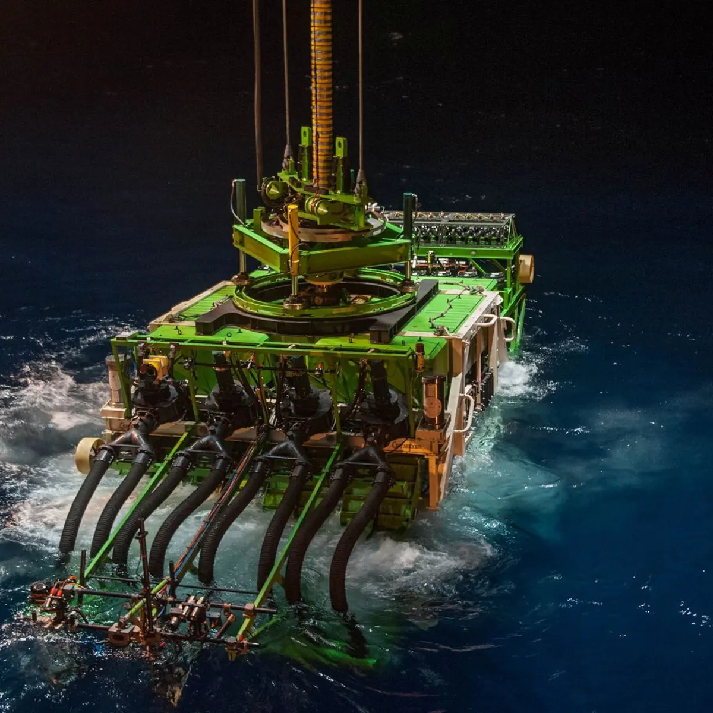
Research Report

Environment
Committee

The Question of regulating deep sea mining to protect marine ecosystems and biodiversity in oceans


Summary
The seabed is one of the most mineral-rich locations on the planet, alongside Antarctica, which means it must be regulated to avoid mass exploitation by coastal-access superpowers for equity’s purposes and for environmental protection of marine biodiversity. These resources can be found on land, and many regulations have been established, however demand has skyrocketed, so nations turn to the deep sea, which contains hundredfold of minerals on land. Resources such as cobalt, lithium, praseodymium and more rare earth metals, mostly in the forms of polymetallic nodules, are used in our daily lives for devices, infrastructure, and many more items. Currently, Deep Sea Mining (DSM) in domestic waters is free to the nation who claims it. However, with international waters, where most of the nodules are located, the ISA (International Seabed Authority) has been pressed to create guidelines to permit DSM, whilst some nations believe that DSM should not be implemented at all due to environmental concerns. For example, the nodules are home to some rare species such as but not limited to the ghost octopus. This is especially concerning since scientists are still studying the deep ocean and do not have a great enough understanding of all the biodiversity that calls the deep ocean their home. In fact, we have only explored 0.001% of the deep seafloor. On the contrary, global demand for rare earth metals is rising exponentially, and economic giants want access to these uncommon materials.

Background Information
In 1970, Resolution 25/2749 (not to be confused with 2749 discussing tensions in Lebanon) on the Declaration of Principles Governing the Sea-Bed and the Ocean Floor, and the Subsoil Thereof, beyond the Limits of National Jurisdiction, which intended to prevent territorial claims of ocean seabed being of any national claim, enforcing the participation of an international regime, and ensure balanced development and environmental degradation. This was to declare the seabed as a “common heritage of mankind”, as said by Malta’s UN ambassador, Arvid Parlo, in his famous speech in 1967, and as an area not to be exploited by any one country, especially those with a coastline or of an island nation. This resolution is mostly beneficial to landlocked countries, since it gives them access to resources they would not have otherwise, however this is disadvantageous for more developed countries that have access to the seabed directly as it limits their ability to consume resources freely.
In 1973, negotiations began on creating UNCLOS (United Nations Convention on the Law Of the Sea), to replace the “Freedom of the Seas” doctrine, which was designed to establish a framework for national oceanic territorial claims, conserve marine life and regulating the excavation of DSM resources, conforming to jurisdiction of international waters by the ISA. This set the divide between the developed nations wanting free access and the developing nations who want equitable access. After 9 years of negotiations, UNCLOS was adopted, then in 1994 it was put into force, more importantly Part XI concerning DSM in accordance with the 1994 Agreement, which allowed the application for UNCLOS originally. By then, UNCLOS had declared maritime zones for the implementation of rights and responsibilities, highlighting different zones including the EEZ (Exclusive Economic Zones), High Seas and The Area, which was directly acclaimed as the “common heritage of mankind” as stated in Resolution 25/2749, to prevent national claims; Part XI is the main focus concerning this topic as it discusses DSM in a market-oriented form, which gained widespread acceptance from states. Note that the USA and some other industrialised nations did not ratify due to concerns of sovereignty, political opposition, overpowering developing nations and undermining of US commercial autocracy.
After UNCLOS, the ISA (Internation Seabed Authority), headquartered in Kingston, Jamacia, issued 15-year exploration contracts to nation-backed company bodies to the Area, China holding the most contracts. Plans were also in place to issue a “Mining Code”, but the ISA did not deliver despite promises. Island nation Nauru, in 2021, set a two-year deadline for the ISA to finalise the construction of the Code, but even now the Code does not yet exist, which has caused political tensions, more reason for nearly 40 countries such as but not limited to Spain, New Zealand, France, Germany, and Switzerland to ask for a moratorium, pause, or ban of DSM to prevent any destruction, before anyone sets forth. This is also backed by the IUCN, and thanks to their motion led to Resolution 122. As of today, plans are still being made to create a Code to protect marine biodiversity whilst keeping up with the global demand for metals.

Main Countries And Organisations Involved
- Nauru
- China
- Russia
- India
- Japan
- USA
- Papua New Guinea
- France
- Germany
- Chile
- New Zealand

Timeline
17th Century – “Freedom of the Seas” doctrine setting the backbone of ocean management despite being archaic.
1960s – Advances in deep-sea mining technology to make it look feasible, concerns rising simultaneously.
1970 – Passing of Resolution 25/2749 on preventing national claim over deep sea territories and as a “common heritage of mankind”.
1973 – Founding talks on UNCLOS (United Nations Convention on the Law Of the Sea)
1982 – Adoption of UNCLOS and foundation of the ISA (Internation Seabed Authority)
1994 – Application of UNCLOS, making the seabed mining rules more market-oriented, and applying Part XI in accordance to the 1994 Agreement.
Early 2000s – ISA commencing distribution of 15-year exploration contracts for The Area to nation-backed companies.
2010s – Only polymetallic nodules and sulphides, and cobalt-rich crusts were allowed to be mined by the ISA’s contract holders.
2019 – Plans for a “Mining Code” to regulate DSM and detail rules against exploitation tasked to the ISA to create
2021 – Nauru declaring that the “two-year rule” bound ISA to a deadline of 2023.
2023 – ISA does not publish the Code upon the deadline, stirring tensions, nations demanding a moratorium of DSM
Today – more negotiations for the creation of the Code are ongoing and highly contested.

Key Questions To Consider
How does your nation benefit/suffer disadvantage from DSM with/without the guidelines implemented?
Is your nation landlocked, therefore is the supply of DSM resources to your nation deficient?
Is your nation coastal or islandic, therefore is the supply of DSM limited by distribution frameworks?
What is the extent of national demand for rare earth metals? What do you use them for?
Does your nation back science groups or NGOs in the research to safely perform DSM if allowing DSM at all?

Wider Reading
https://www.sciencedirect.com/science/article/abs/pii/S2214790X18303137
https://www.unepfi.org/publications/harmful-marine-extractives-deep-sea-mining/
https://www.unep.org/resources/publication/deep-sea-mining
Deep-sea mining: Exploration rights under ISA regulation
The Mining Code - International Seabed Authority
A/RES/25/2749 - Declaration of Principles Governing the Sea-Bed and the Ocean Floor, and the Subsoil Thereof, beyond the Limits of National Jurisdiction - UN Documents: Gathering a body of global agreements
UNCLOS: The United Nations Convention on the Law of the Sea – Maritime Education
What We Know About Deep-Sea Mining and What We Don’t | World Resources Institute
Hypocri-sea: The United States’ Failure to Join the UN Convention on the Law of the Sea
Agreement on Part XI UNCLOS
Momentum for a Moratorium - Deep Sea Conservation Coalition
Exploration Contracts - International Seabed Authority
WCC_2020_RES_122_EN.pdf

