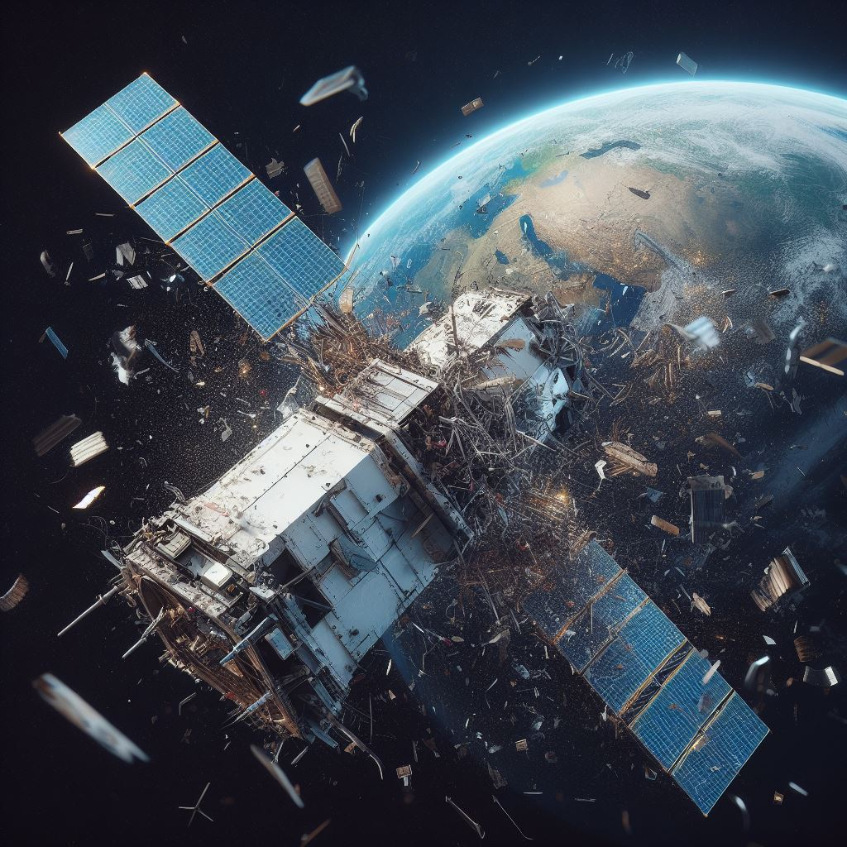
Research Report

Environment
Committee

The Question of Mitigating the environmental threat of space debris in Earth Orbit


Summary
Space debris is becoming one of the most significant dangers to the long-term use of space. It is the name given to defunct satellites, rocket bodies, and hundreds of thousands of pieces of fragments that are orbiting the Earth at extremely high speeds. Even a small number of debris can destroy a working satellite, and with many more satellites being launched annually, the chances of collisions are also increasing. If not addressed, space debris can make certain orbits unusable, threatening global communications, weather forecasting, navigation, and even national security. This topic welcomes the committee to discuss both remedial and preventive measures, balancing national interests with the need for international cooperation.

Background Information
The problem of space junk began with the first satellite, Sputnik 1, in 1957 and has built up steadily since then. There are over 30,000 objects larger than 10 cm being monitored in orbit today, but there may be millions of smaller objects that pose a hazard even though they cannot be tracked.
One of the greatest fears is the Kessler Syndrome, proposed by NASA scientist Donald Kessler in 1978. It is a cascading reaction where collisions between debris generate more debris until the process gets out of control and space becomes hazardous for satellites and spacecraft.
Several events have exacerbated the issue. In 2007, China conducted an anti-satellite missile test that generated more than 3,000 pieces of trackable debris. In 2009, a dead Russian satellite collided with a US Iridium satellite, producing thousands more. More recently, in 2021, a Russian ASAT (Anti-Satellite Weapon) test endangered astronauts aboard the International Space Station.
It is not only a matter of protecting satellites, but also a matter of protecting services that individuals utilize every day: GPS, banking, weather prediction, climate research, and communications. Unless the world acts decisively, orbital space can be rendered unusable for future generations.

Main Countries And Organisations Involved
- United States
- Russia
- China
- European Space Agency (ESA)
- Japan (JAXA)
- India (ISRO)
- United Nations (UNOOSA)
- Private Companies: Starlink (SpaceX), OneWeb, and others launching "mega-constellations," which increase both opportunities and dangers.

Timeline
1957: Launch of Sputnik 1.
1978: Kessler Syndrome theory established.
1996: French satellite Cerise hit by debris from dead rocket.
2007: China ASAT test creates thousands of debris.
2009: Iridium–Cosmos collision adds ~2,000 trackable objects.
2019: India conducts ASAT test.
2021: Russian ASAT test imperils ISS astronauts.

Key Questions To Consider
How to make nations accountable for the space debris they create?
Should ASAT tests be banned completely?
How to persuade private firms to dispose of satellites responsibly?
Who pays for debris removal technology?
Is there a role for binding international treaties, rather than voluntary guidelines?

Wider Reading
NASA Orbital Debris Program: https://orbitaldebris.jsc.nasa.gov
ESA Space Debris Office: https://www.esa.int/Safety_Security/Space_Debris
UNOOSA Debris Mitigation Guidelines: https://www.unoosa.org
BBC Future – "The Kessler Syndrome Explained" (2021)
The Diplomat – "Russia's 2021 Anti-Satellite Test: What It Means for Space Safety"

