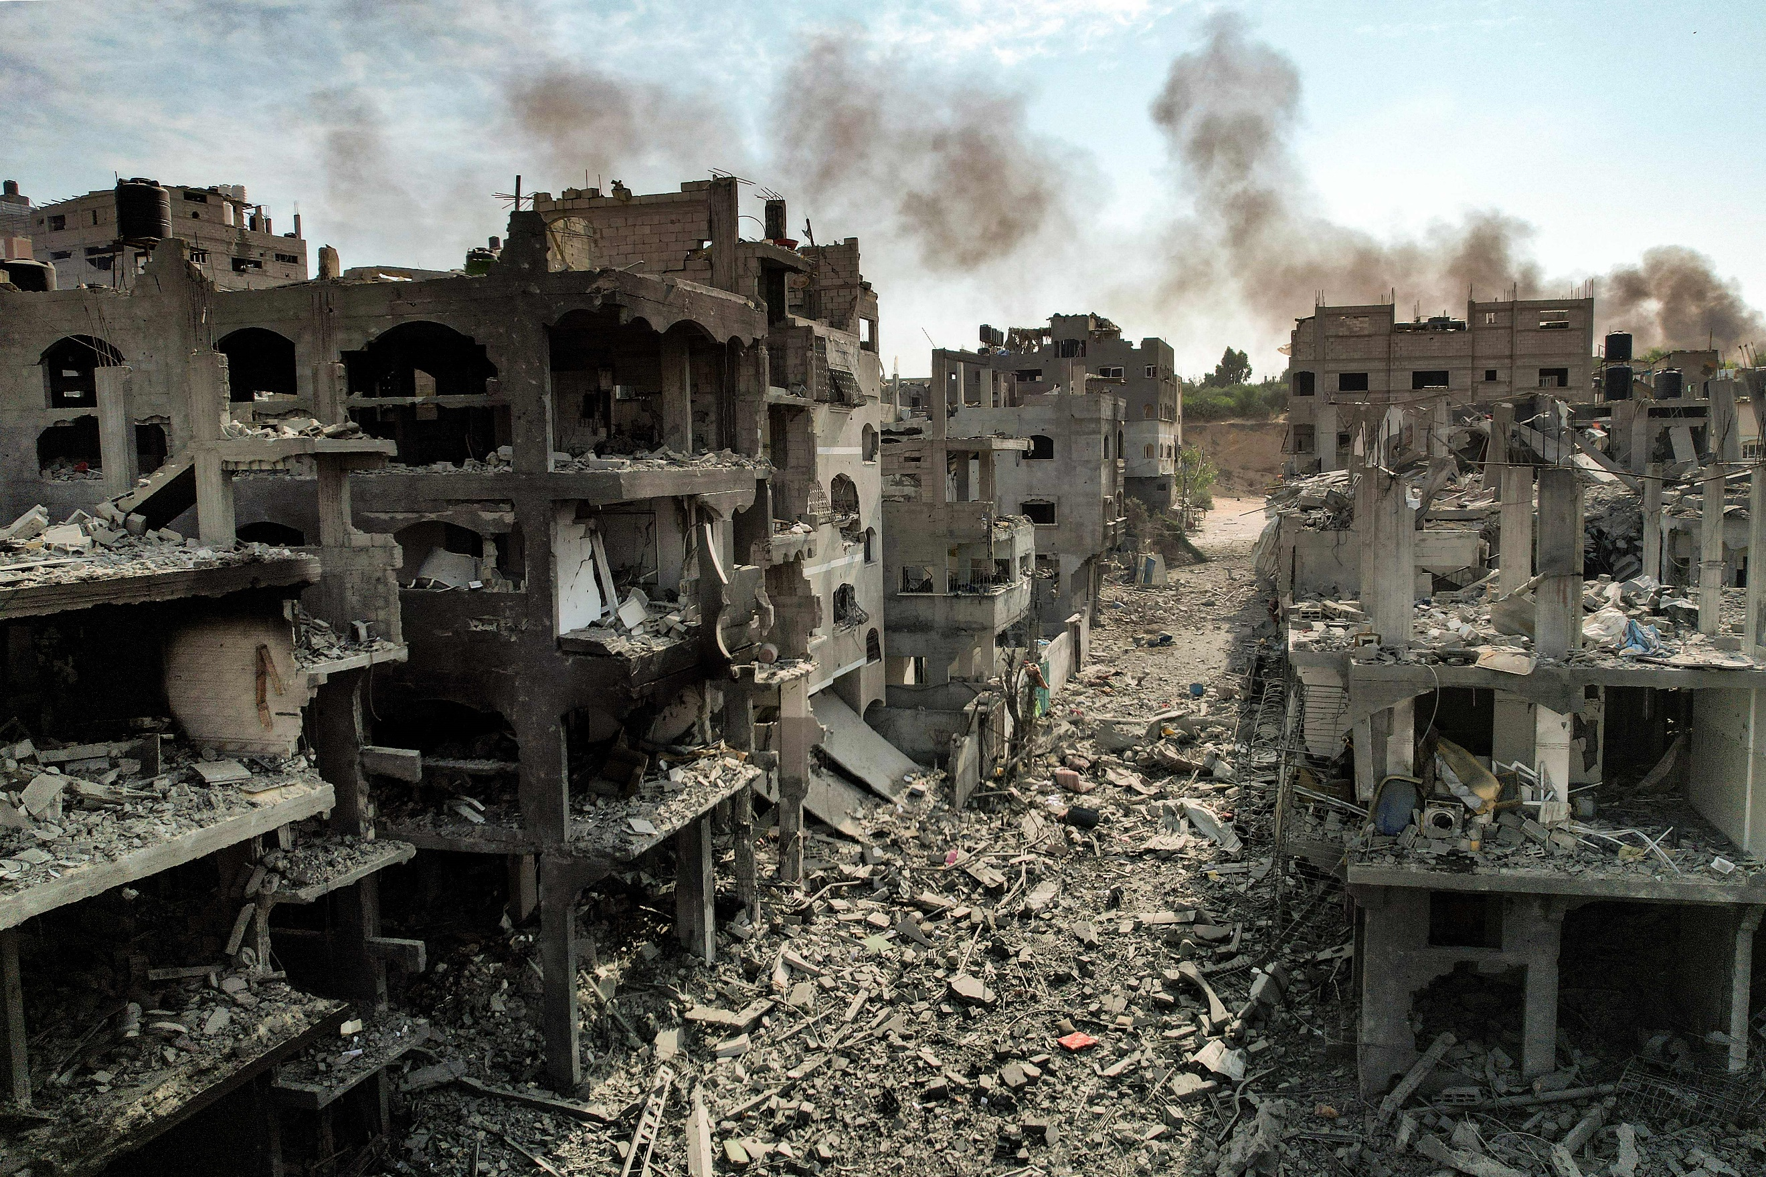
Research Report

Security Council

The Question of the Evolving Situation in Israel and the Palestian Territories

Due to the very early days of the conflict in which this report was written, it is but a skeleton of the depth and research expected by delegates necessary to properly address this issue. Delegates should also note that while the focus may be on the recent conflict, resolutions aiming to find long-term solutions that address the problem more broadly may become the focus of debate.

Background Information
The Israeli-Palestinian conflict is one that predates the founding of the United Nations. The Jews occupied Palestine in Biblical times under the rule of ancient Rome, but were expelled in 70CE. In the centuries following, Palestine became an Arab/Muslim land, and was part of the Ottoman Empire until its collapse at the end of WW1. The territory came under British rule, with Jewish immigration in the 1920s and 1930s causing tensions to rise. In 1945, following WW2 and the horrors of the Holocaust, pressure increased on the British to take 100,000 Jewish settlers into Palestine. Britain refused, leading to a Jewish terrorist campaign. In 1947, Britian asked the Un to intervene, and Britian left in 1948.
The UN proposed the partition of Palestine, but when the day after the state of Israel was proclaimed on May 14, 1948, Iraq, Lebanon, Syria, Jordan and Egypt attacked Israel. Over the following years, tensions rose in the region: In 1967, the Six-Day War greatly increased Israel’s territory, and in 1973, Arab nations once again attacked Israel in the Yom Kippur War. Years of conflict were succeeded by what seemed to be years of progress, with the signing, first of the Camp David Accords between Israel and Egypt, then of the Oslo 1 and Oslo 11 Accords, which mediated the conflict and enabled mutual recognition between Israel and the newly established Palestinian Authority. This history of the conflict is immense, and this is but a brief, simplified summary—a deeper understanding of the conflict is advised.

Issues
Hamas is an Islamist militant group inspired by the Palestinian Muslim Brotherhood that took over the Gaza Strip after defeating longtime majority party Fatah in 2006. The USA and EU designate Hamas as a terrorist organisation due the armed resistance, including suicide bombing and rocket attacks, against Israel. On October 7, 2023, Israel declared war on Hamas following its surprise assault on southern Israel in the deadliest attack on the country for decades. This was followed by a directive from the defence minister to the Israeli Defence Forces (IDF) to carry out a “complete siege” of Gaza. Gaza is running out of water, fuel and supplies amid an Israeli aid blockade.
In the first two days of fighting alone, approximately 800 Israelis and 500 Palestinians were killed. Increasing loss of life is of primary concern in the conflict. However, escalation is also an enormous concern. Iran has a well-established patronage relationship with Hamas, and there are concerns that other groups with Iranian backing, most concerningly, Hezbollah, will be drawn into the war. Israel has already conducted cross-border operations into Lebanon, where Hezbollah is based.

Countries Involved
Israel, Palestine (UN observer state), Lebanon, Syria, Iran, Saudi Arabia, UAE, USA

Useful Links:
https://www.cfr.org/global-conflict-tracker/conflict/israeli-palestinian-conflict
https://www.cfr.org/backgrounder/what-hamas
https://www.bbc.co.uk/news/world-middle-east-54116567

