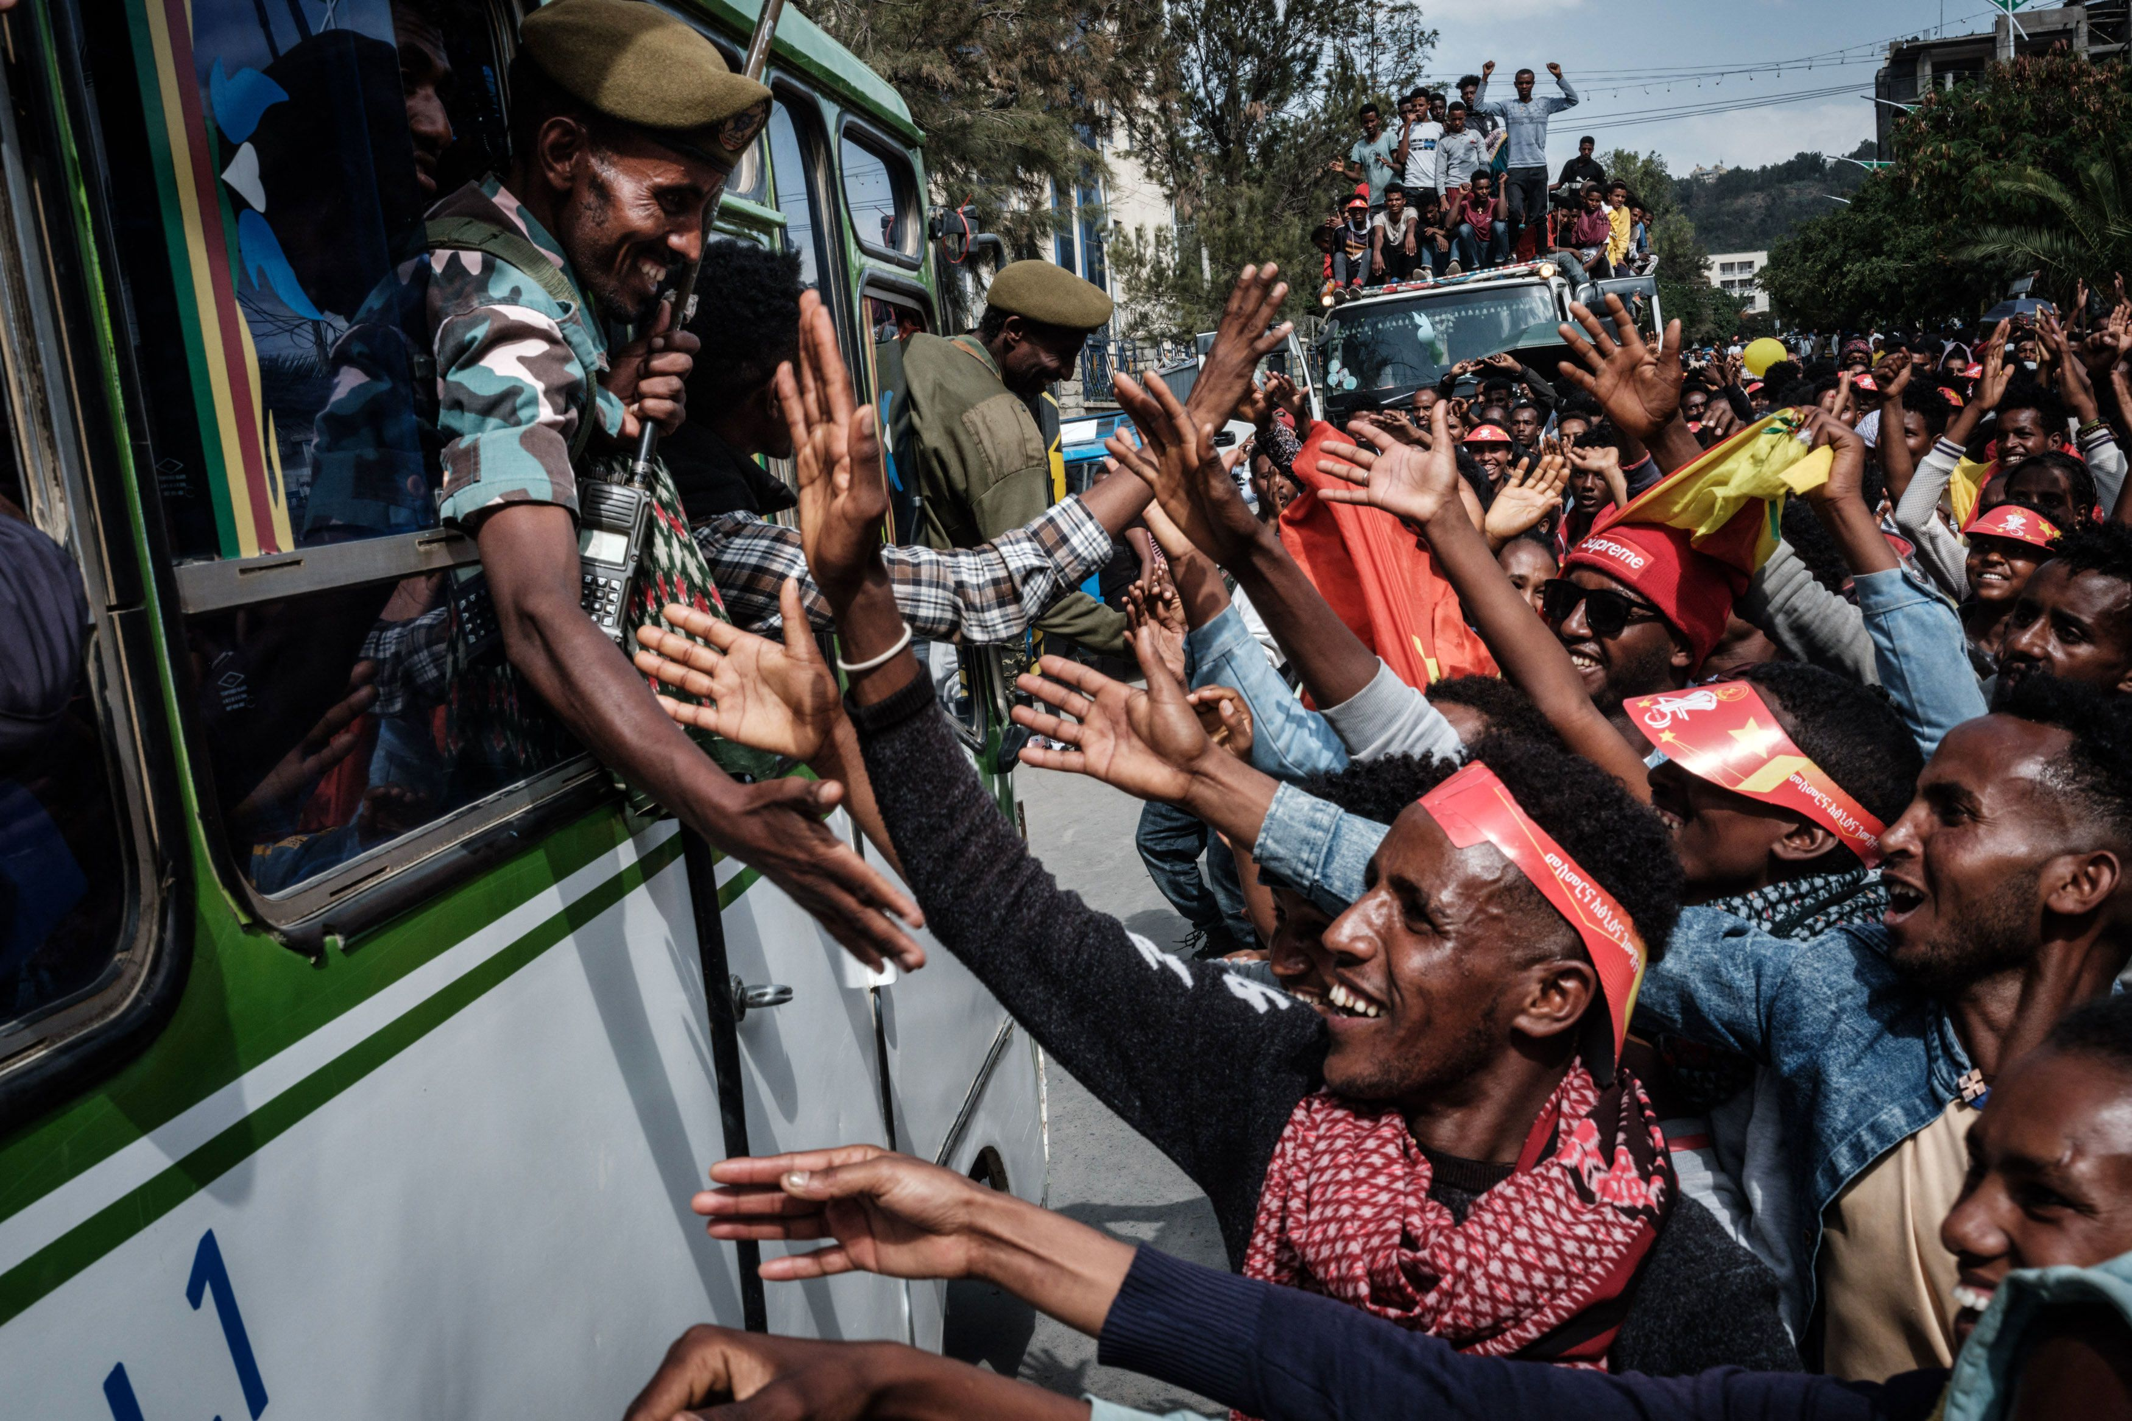
Research Report

Special, Political, and Decolonisation

The Question of the Conflict in Ethiopia

Background Information
The Ethiopian Conflict in Tigray, which began in November 2020 and has recently rebegun after an agreement to halt hostilities was endorsed by the TPLF and the Ethiopian central government on November 2, in Pretoria, South Africa. Throughout the conflict it has been a complex and multifaceted crisis that has gained much international attention.

Historical Context
Ethiopia's Federal System: Ethiopia has a long history of ethnic diversity and regional tensions. In 1991, after the fall of the Derg regime, the Ethiopian People's Revolutionary Democratic Front (EPRDF) established a federal system, granting significant autonomy to regional states. Tigray was one of these regional states, and its dominant political force was the Tigray People's Liberation Front (TPLF).
The EPRDF's Rule: The EPRDF, led by TPLF, governed Ethiopia for nearly three decades, overseeing both economic growth and authoritarianism. Its rule ended in 2018, when Abiy Ahmed, an Oromo, assumed the position of Prime Minister and initiated political reforms.

Causes of the Conflict
The conflict's roots can be traced back to political tensions and disputes between the TPLF and the federal government. These tensions were exacerbated by the federal government's push for centralized authority. Furthermore, Ethiopia's diverse ethnic makeup played a significant role in the conflict. As the TPLF tried to protect its regional interests, ethnic rivalries became more and more relevant. Finally, security concerned have also been a prevalent issue, the Ethiopian government claimed the TPLF attacked a federal military base in Tigray, prompting the military intervention. This was driven by security concerns and a desire to restore federal authority.

Recent developments
After a series of failed ceasefires, in September 2022, Tigrayan leadership committed to hold fire in order to participate in negotiations led by the AU after a series of failed ceasefires. A cessation of hostilities agreement was signed by the TPLF and Ethiopian central governmnet on November 2 in Pretoria, South Africa.
Despite some reduction in the Tigray conflict, ongoing tensions among regions and armed groups are challenging Abiy's efforts to unite Ethiopia. In 2022, Ethiopia arrested thousands in Amhara, fearing the growing power of a militia. They also failed to prevent attacks on Amhara people in Oromia and relocated residents near the Tigray border in Afar.
In 2023, violence has decreased, but challenges persist in implementing peace deals, including regional force integration and rebel negotiations. In April, Abiy faced protests and resistance when integrating regional forces. He also started peace talks with the Oromo Liberation Army, but by June, focus had shifted to eliminating paramilitaries to preserve national unity.
In the Amhara region, conflict flared as the federal government clashed with the Fano militia. The group, once an ally against Tigrayan forces, now accuses Addis Ababa of neglecting regional security. A senior official accused Fano of trying to overthrow the government, prompted by government's loss of control in some areas. Ethiopia declared a six-month state of emergency in Amhara to address the situation, with reports of gunfire and military aircraft.

Issues
The conflict has resulted in a severe humanitarian crisis, with millions of people in need of food, shelter, and medical assistance. Access to aid has been constrained due to ongoing violence, and in June 2023, USAID, and the World Food Programme (WFP) halted assistance efforts when they uncovered significant theft of food by Ethiopian soldiers and officials. This suspension resulted in numerous fatalities from starvation as humanitarian workers tried to adjust their food distribution methods.
Tens of thousands of people have been displaced, both internally, and as refugees in neighbouring countries. This has created a major refugee crisis. In 2023 there were more than four million internally displaced people.
There have been numerous allegations of human rights abuses, including massacres, sexual violence, and forced displacement, committed by both Ethiopian and Eritrean forces. In 2023, the UN requested four billion dollars to provide aid to twenty million people affected by conflict.
The conflict has implications for the political stability of Ethiopia and the broader Horn of Africa (Eastern Africa) region, with the potential for ethnic and regional conflicts to spread.

Countries Involved
Ethiopia, Neighbouring countries (Eritrea, Sudan and Kenya), USA (aid to Ethiopia), EU, UK, France, and all African Union Member States

Useful Links:
https://www.cfr.org/global-conflict-tracker/conflict/conflict-ethiopia
https://en.wikipedia.org/wiki/War_in_Amhara
https://www.wilsoncenter.org/blog-post/reflection-conflict-amhara-region-ethiopia

