Cormac Mountain & Simreth Dhingra Miko Keen & Lyra Blagden
Secretary Generals Deputy Secretary Generals

Delegate Handbook
Dear Delegates
It is with great pleasure that we welcome you to our Conference.
The Conference is open to all students of all abilities and our committee topics have been selected with this in mind. We hope that you enjoy fruitful debate during the day.
At Lingfield we encourage lively discussion but emphasise the importance of diplomacy and co-operation to solve problems and come to effective solutions. To help with the smooth running of committee sessions. we encourage you to submit resolutions for your one or both of the topics in your committee. These should be sent directly to your chairs whose email addresses are listed on the committee reports. Additionally, to gain the most out of this conference, delegates should prepare an opening speech. With a prepared speech in hand, you will feel more confident and will feel better prepared to take part in discussion.

Dress Code
Formal attire

Order of the day

8:30 – 9:00 | Arrival, coffee and tea
9:00 – 9:30 | Opening Ceremony
9:30 – 11:00 | Committee Sessions
11:00 - 11:30 | Break
11:30 – 13:00 | Committee sessions
13:00 – 14:00 | Lunch
14:00 – 15:00 | Committee sessions
15:00 – 17:00 | General Assembly
17:00 – 17:30 | Closing ceremony

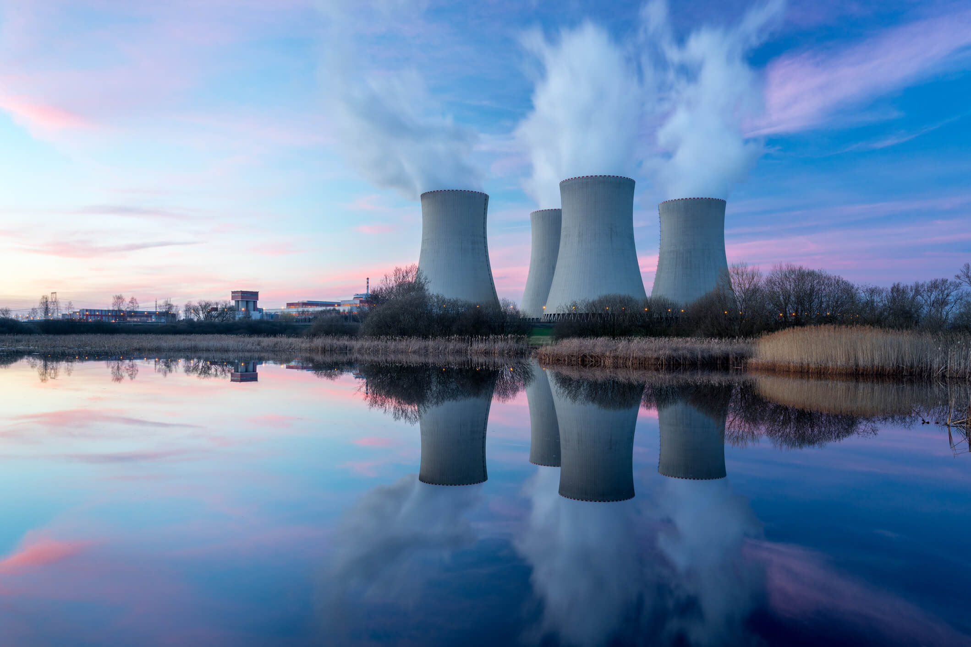
Research Report

Disarmament and International Security

The Question of The Proliferation of Nuclear Technology To Non-Nuclear Nations

Background Information
In recent years the number of nuclear powers has dramatically increased across the world with the number of nuclear powers now totaling at nine with it estimated that over ten countries posses the means to develop such weapons in the future if they desire, some of which have already started this program. With this in mind, the UN would like to encourage the discussion among nations towards the de-nuclear weaponization of countries across the world and to help deter non-nuclear nations from acquiring nuclear weapons or weapons of mass destruction involving nuclear technology.

Issues
Countries such as Iran are actively suspected to be trying to develop nuclear weapons. This is in response to the increase in nuclear weapons in the region such as the perceived Israeli stockpile of nuclear weapons increasing. The UN is advising all countries co-operate to find a solution that deters non-nuclear nations from trying to gain nuclear weapons as well as reducing the need for them to possess them by countries currently in possession of nuclear weapons taking steps to reduce this need.
Some countries such as Japan, the Netherlands and Germany are examples of countries which have the capability to develop nuclear weapons but do not feel the need to pursue this mission so should be looked at as an example of why this is the case. In addition, South Africa serves as a shining example of a country which once was a nuclear weapon state giving up its nuclear weapons.

Key Questions
Delegates should consider how best to address the increase of the development of nuclear weapons from non-nuclear weapon nations.
Delegates could seek to address the increase in the desire of countries to posses nuclear weapons due to other countries actions.
Delegates should consider the extent of the UN regulation and deterrence for non-nuclear weapon states to pursue these goals needed to maintain peace and security worldwide.
Delegates could consider the implications, positive and negative, of nuclear energy, with a particular focus on the potential for weapons the technology holds.

Countries Involved
USA, Iran, Israel, China, Russia, UK, France, Pakistan, India and DPRK

Useful Links:
https://www.armscontrol.org/factsheets/Nuclearweaponswhohaswhat
https://en.m.wikipedia.org/wiki/Treaty_on_the_Prohibition_of_Nuclear_Weapons

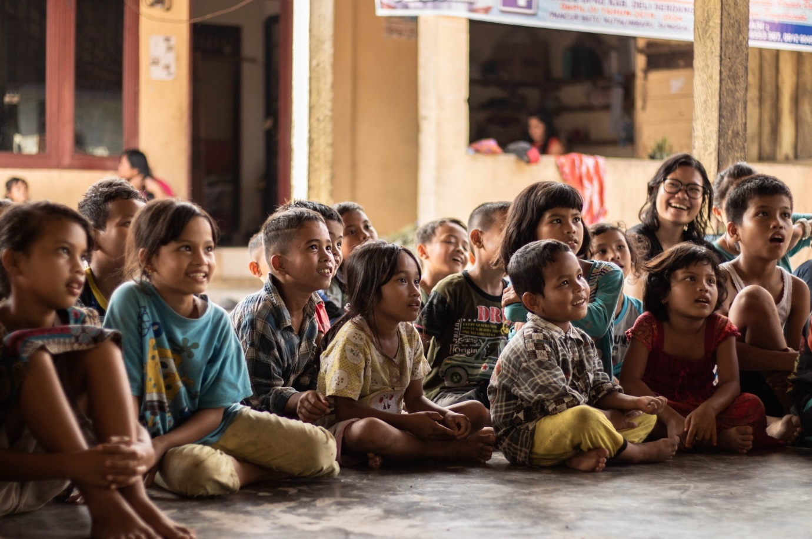
Research Report

Disarmament and International Security

The Question of Modern Slavery and People Trafficking in Africa and The Middle East

Background Information
In the last four decades, slavery and people trafficking have exploded across the Middle East, with countries such as Saudi Arabia and Qatar using the people trafficking of migrant workers from poorer countries in large numbers as slave labour for construction projects. The UN recognises the importance of tackling this issue directly, as and I nothing is done, it fears that this increase in people trafficking could reach levels as high as 50 million people in the coming decade.

Issues
Saudi Arabia has an estimated 740,000 people living in modern slavery. This is due to its policy of importing migrant workers and stripping them of their passports, effectively trapping them in the country to work for extremely low pay—crippling them in poverty.
An estimated 3.8 million people in Africa are in forced labour. Countries with the highest levels of modern slavery included Eritrea, Mauritania, and South Sudan. Often, as is the case in Mauritania, slavery exists along ethnic boundaries. Over 200,000 people have been trafficked to the Middle East over the past two decades, with Yemen and the United Arab Emirates having amongst the highest human trafficking levels.

Key Questions
Delegates should consider whether countries in Middle East and Africa are taking sufficient action to prevent human trafficking in their countries or actively encouraging the process.
Delegates should consider agreements that could be put in place to curb modern slavery and people trafficking within Africa and the Middle East.
Delegate not representing countries in either region should recognize the importance that stopping human trafficking and modern day slavery plays on the international stage, and therefore work hard to curb its prevalence everywhere.

Countries Involved
Saudi Arabia, Qatar, UAE, Eritrea, Mauritania, South Sudan, USA, UK, France, and Yemen.

Useful Links
https://www.walkfree.org/global-slavery-index/country-studies/saudi-arabia/
https://en.m.wikipedia.org/wiki/Human_trafficking_in_the_Middle_East#:~:text=In%20the%20Middle%20East%2C%20some,camel%20jockeying%20of%20young%20boys

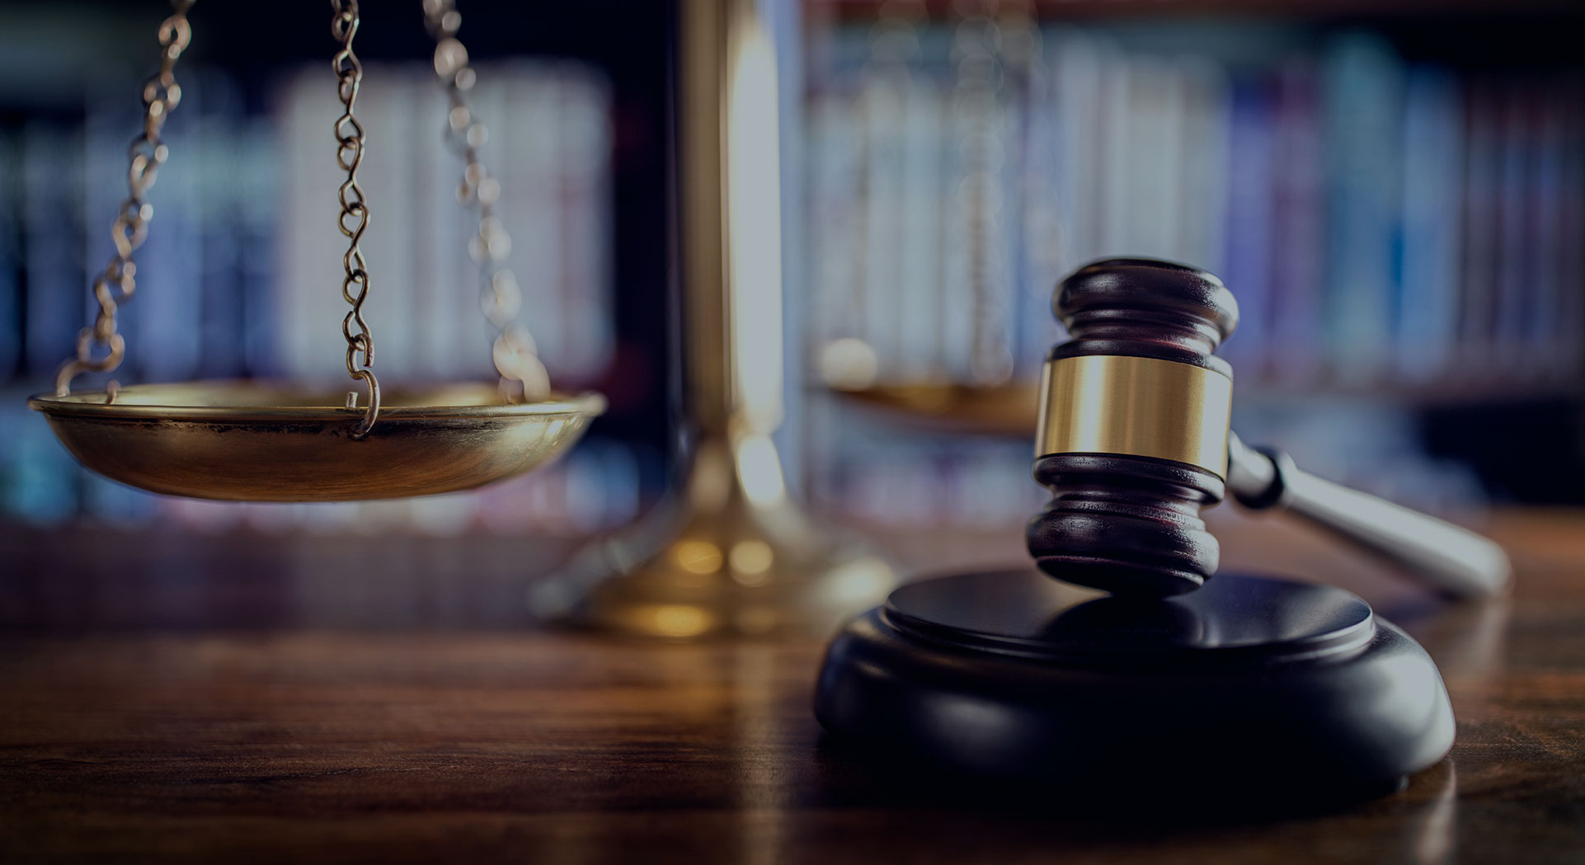
Research Report

Economic and Financial
Affairs Council

The Question of The International Tax Havens

Background Information
A tax haven refers to a location with exceptionally low tax rates for non-domiciled investors. Tax havens are often viewed negatively for political reasons. A proportion of tax havens disclose zero taxation (tax neutrality), whilst modern corporate tax havens reject any association with such tax rates, instead implementing non-zero headline tax rates but with use of base erosion and profit shifting (BEPS) to achieve effective tax rates close to zero, impacting global tax revenues. Over 15% of countries are considered to have some form of tax haven, with financial services providing prosperity to offshore financial centres (OFCs) often leading to an overly inflated GDP per capita due to accounting practices. Previous efforts to combat tax havens included tax transparency and data sharing. However, the rise of OEDC compliant corporate tax havens using BEPS tools have resulted in rising criticism, exposing the gap between the public perception of tax havens as tropical islands and the reality of modern corporate tax avoidance. This resulted higher tax jurisdictions, causing the US and numerous EU states to leave the OECD BEPS project in 2017 and 2018—introducing anti-BEPS tax measures to increase taxes paid by corporations, adopting hybrid tax systems, and proposing digital services tax.

Issues
The use of tax havens reduces the total tax revenue in some countries. This is because capital held in tax havens leaves tax bases—this is estimated to be between $7 - $10 trillion.
Tax havens can have substantial impacts on LEDC’s, as less tax revenue is taken in, leading to a reduction in public and social services and the provision of essential infrastructure. This in tern may have negative implications on economic growth. This leads to inequality between Member States: by allowing wealthy corporations to shield their profits, those in LEDC’s suffer. Additionally, the lack of transparency by firms facilitates money laundering, tax evasion, and illicit financial flows.
Countries Involved
The Bahamas, USA, UAE, British Virgin Islands, Switzerland, Luxemburg, Singapore, and the Netherlands, as well as any Member State facing accusations of being a tax haven or facing negative economic effects as a result of tax havens.

Relevant Treaties and Organisations
The Common Reporting Standard (CRS) is an international standard for the automatic exchange of financial account information between tax authorities, facilitating the sharing of financial data among participating countries to combat tax evasion.
Base Erosion and Profit Shifting (BEPS) aims to address tax avoidance strategies commonly used by trans-national corporations. BEPS provides recommendations, including but not limited to practices for countries to prevent profit shifting to tax havens.
The Financial Action Task Force (FATF) addresses tax evasion and financial secrecy, in addition to money laundering and financing terrorism.
The United Nations Model Double Taxation Convention aids developing countries in negotiating tax treaties with other Member States and promotes fair and equitable taxation practices.
The Global Forum on Transparency and Exchange of Information for Tax Purposes reviews the implementation of international standards for exchange of tax information between Member States, as well as compliance with the standards of transparency and exchange of information.
European Union (EU) Initiatives including the Anti-Tax Avoidance Directive (ATAD) and the Automatic Exchange of Information (AEOI) under the Common Reporting Standard have been introduced in an effort to reduce tax evasion.

Useful Links:
https://www.wsj.com/articles/corporations-push-profits-into-tax-havens-as-countries-struggle-in-pursuit-study-says-1528634659
https://www.imf.org/en/Publications/fandd/issues/2019/09/tackling-global-tax-havens-shaxon
https://www.bloomberg.com/opinion/articles/2017-04-11/tax-havens-can-be-surprisingly-close-to-home
https://www.oecd.org/tax/beps/background-brief-inclusive-framework-for-beps-implementation.pdf
https://www.weforum.org/agenda/2020/02/how-do-corporate-tax-havens-work/
https://www.theguardian.com/commentisfree/2017/nov/08/tax-havens-dodging-theft-multinationals-avoiding-tax

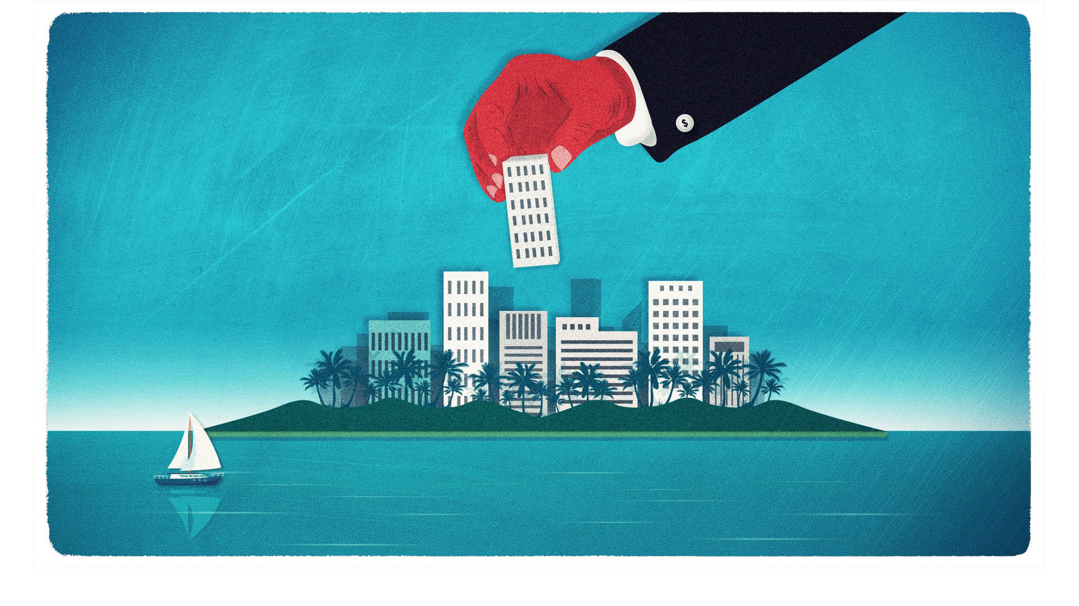
Research Report

Economic and Financial
Affairs Council

The Question of The Embezzlement of International Funds

Background Information
Embezzlement is a crime under international law, consisting of the withholding of assists, and theft of assets from a corporation or organisation, in addition to the misuse of those funds, for a purpose that wasn’t initially intended. In conjunction to this, making the distinctions can result in complications, when dealing with misappropriations of property by employees. To prove embezzlement, it must be proved that the employee had possession of the goods by his or her own employment, that the employee had formally delegated to have substantial control over the funds. The act of embezzlement involves falsifications of records, but should not be confused with skimming, occurring when income is underreported, and hence pocketing the difference. Over 85% of embezzlement cases included a manager or higher, with over 70% of cases going unnoticed for over a year, and over 31% lasting over 3 years. However, over 97% of firms were “confident the anti-fraud control in place...would prevent future embezzlements” occurring in the future.

Issues
A high proportion of donor funding occurs in LEDC’s, as a result, keeping track of where the funds are spent can be difficult. Further to this, the time pressure involved with the spending of these funds can cause the aims of the spending to be compromised, due to the urgency of the situation. An example of this includes the former executive director of the International Civil Society Support (ICSS), embezzled over £113 000 from a Dutch based civil society, with these funds were over £550 000 of suspicious transactions undertaken by the individual. The reduction in funds from international firms, partially NGO’s and charitable organisations leads to a reduction in investment in member states, causing a reduction in economic growth, potentially resulting in job loses, and deprivation in LEDC’s.

Key Issues and Questions
How can the transparency in the movement of funds be increased?
How can the embezzlement of international funds be reduced?
What incentives could be put in place to reduce embezzlement of international funds?

Countries Involved
USA, UK, Germany, Netherlands, Nigeria, Liberia

Useful Links:
https://ti-health.org/corruption-type/embezzlement-and-misuse-of-donor-funds/
https://www.theglobalfund.org/en/oig/updates/2022-01-24-embezzlement-of-funds-from-global-fund-partners/
https://www.justice.gov/usao-cdca/pr/massive-international-fraud-and-money-laundering-conspiracy-detailed-federal-grand-jury
https://www.law.cornell.edu/wex/embezzlement
https://www.legislation.gov.uk/ukpga/1916/50/enacted
https://www.hiscox.com/documents/2018-Hiscox-Embezzlement-Study.pdf
https://legacy.acfe.com/report-to-the-nations/2020/
https://www.justice.gov/archives/jm/criminal-resource-manual-1005-embezzlement
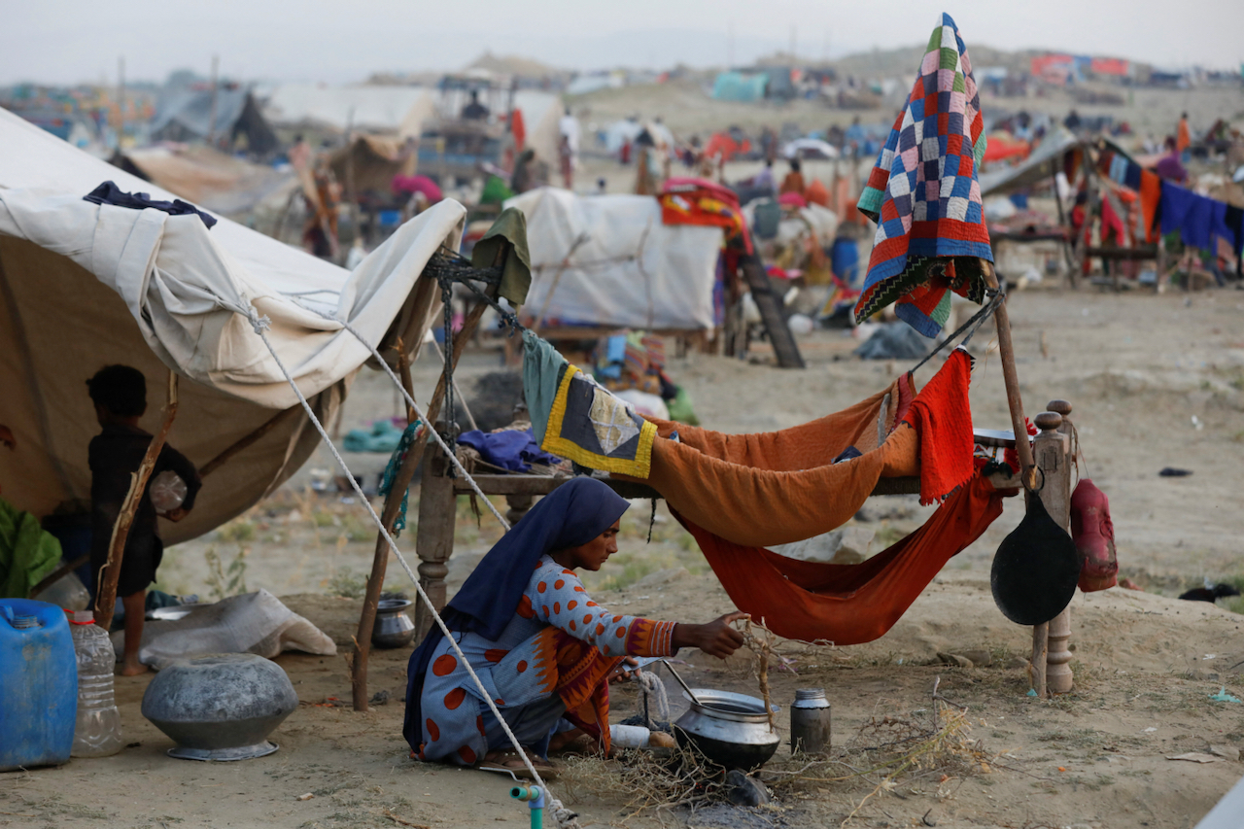
Research Report

Environmental Committee

The Question of Climate Refugees

Background Information
The volume of greenhouse gases emitted into our atmosphere has grown exponentially over the last 150 years, first reaching over 50 billion tonnes annually in 2010. This has resulted in a dramatic increase in the quantity and severity of extreme climate events that have taken place in recent years. This in turn has led to an ever-increasing number of climate refugees, especially after disasters such as flooding or droughts. As outlined in the 1951 Refugee Convention and the 1967 Protocol, refugees have the protected right to seek asylum. It is vital that the international community can find housing for all these displaced peoples, and treatment for them to be fair and equal, no matter the circumstances or characters. The issue of climate refugees stretches across the planet, from Central America to Central Asia. Over 84% of the world’s habitations are in areas significantly affected by climate change, notably through the rising prevalence of extreme weather events and forest fires, as well as the rise of global sea levels. This means that forecasting into the future, the quantity and vulnerability of refugees will only increase. However, as the most vulnerable areas of the world are Afghanistan, West and South-East Africa, and Bangladesh and the Bengal region, extra focus may need to be put on these areas.

Issues
With an increase in the number of displaced people, the question arises as to where to house them, including the extent and quality of such housing. Projects for housing could be started now in accordance with forecasts. Especially when considering there could be a total of around 1.2 billion displaced people globally, it is obvious that something should be done now. Without a place to stay these people will have much more difficult lives, and in less developed areas with not as much access to facilities, this could mean succumbing to disease and illness.

Key Questions
Delegates should be aware the basic human right to seek asylum, and how could relate to this situation.
Delegates could consider the state of their own countries, and whether they have the capability to house refugees, or if they need additional support, perhaps through funding.
Delegates should consider the outcome of these peoples and the world.
Delegates could discuss about putting preventions in place before they become refugees.

Countries Involved
USA, UK, France, Germany, China, Ghana, Mozambique, India, Egypt, and any country that will be subject to the immigration or emigration of climate change refugees.

Useful Links:
""Climate Refugees," Explained"
"The White House Report on the Impact of Climate Change on Migration"
"2021 Global Report on Internal Displacement"
"Economic Recovery after Natural Disasters"
"Environmental Influences on Human Migration in Rural Ecuador"
Key Principles for Policy Making on Migration, Climate Change & the Environmental Degradation
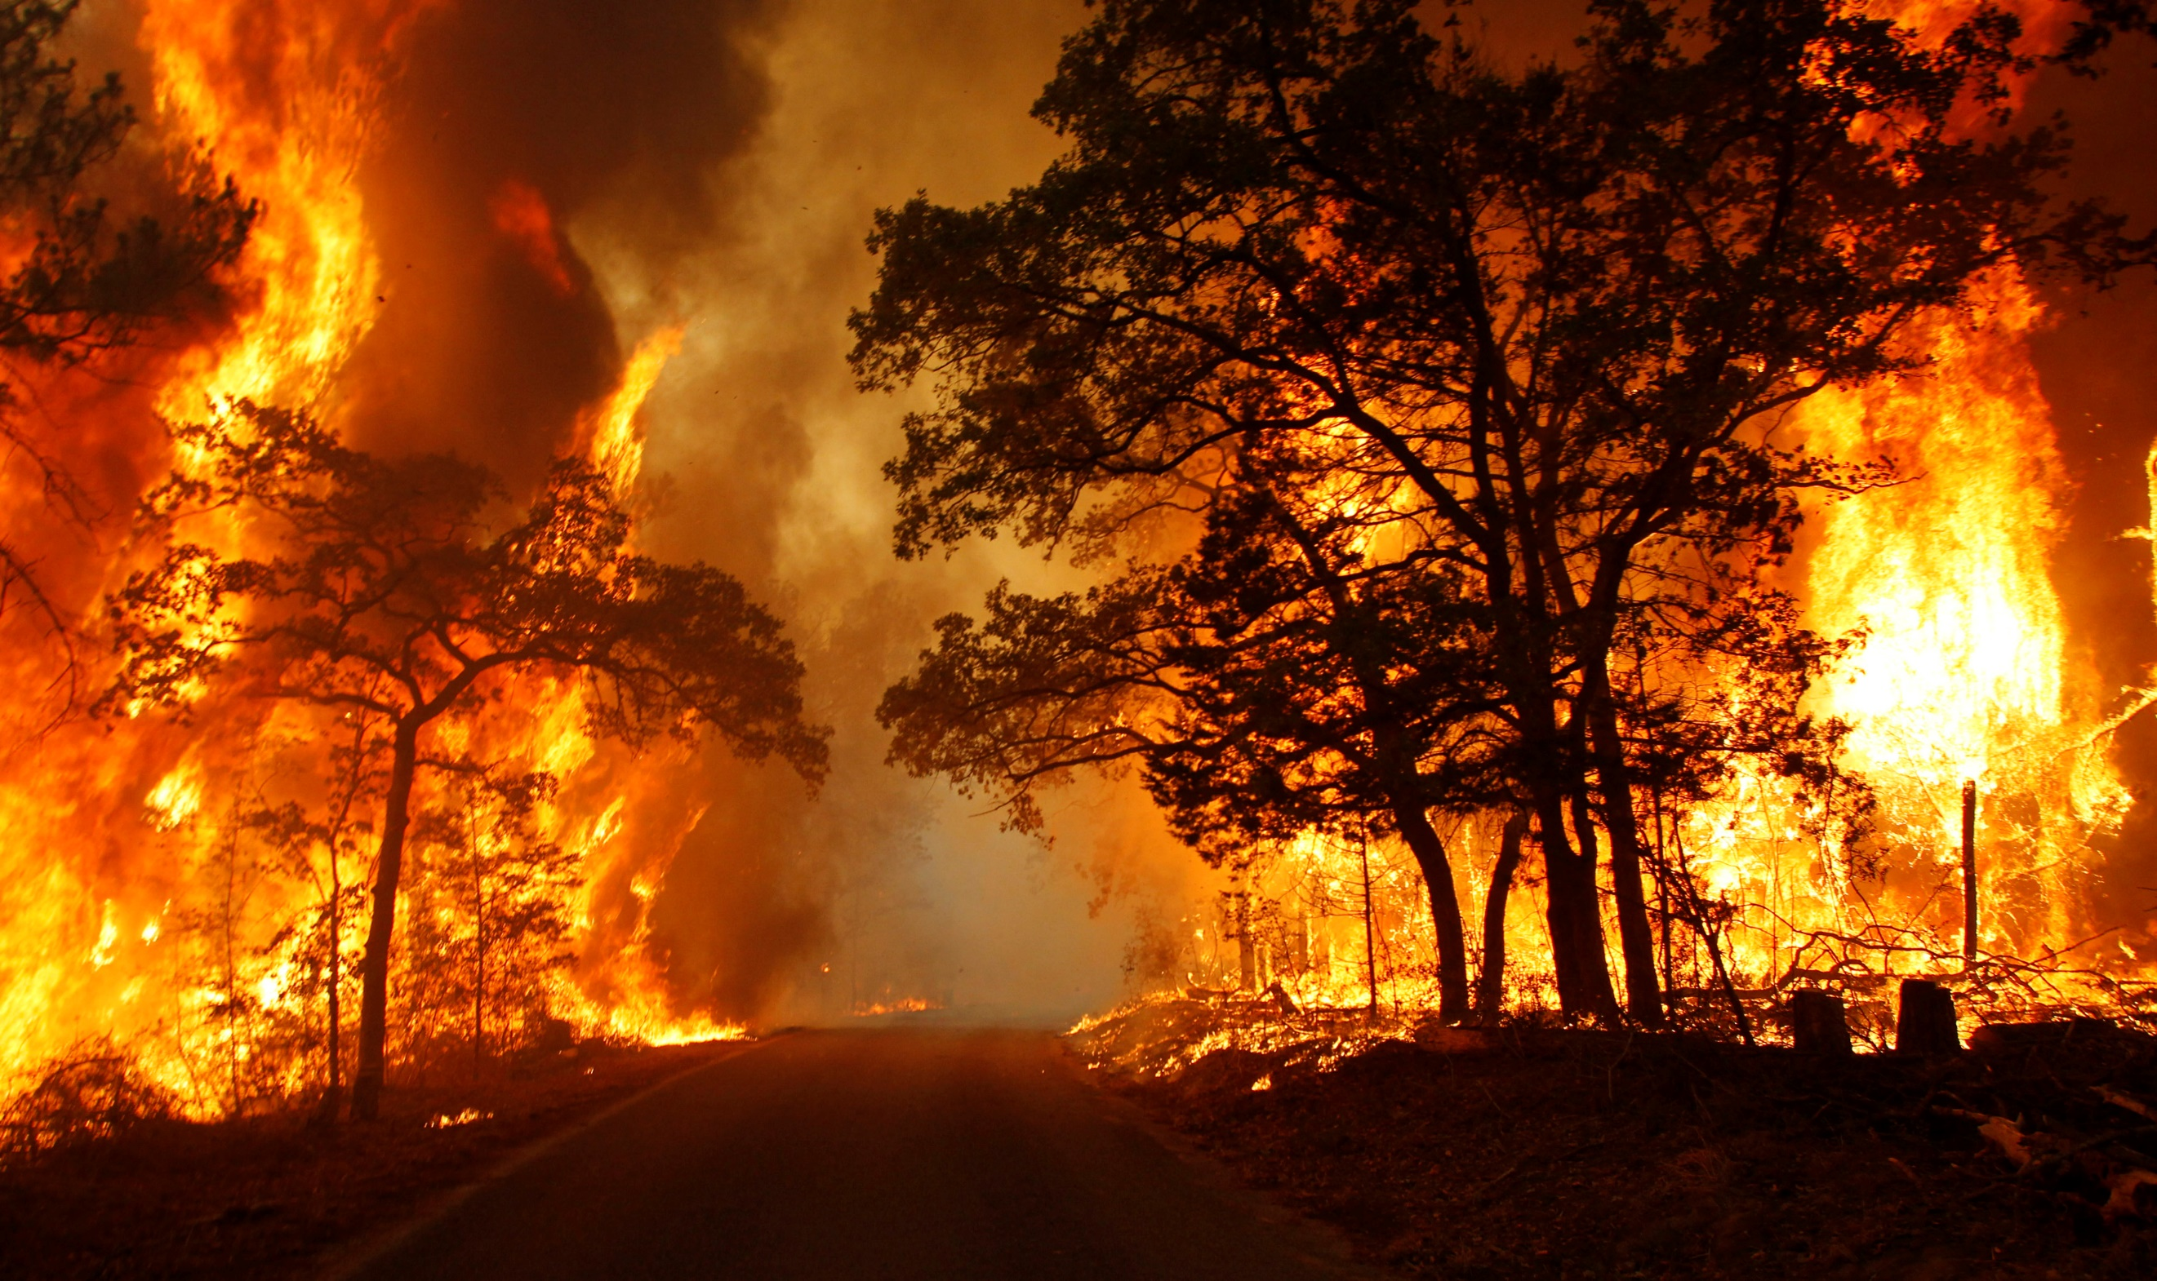
Research Report

Environmental Committee

The Question of Disaster Response to Extreme Natural Events

Background Information
With the rapidly increasing temperature of the world, globally, there has been an ever increasing rate of extreme weather and other natural events, including forest fires. In the USA, torrential downpour, rising sea levels and rampant flooding are clear examples of this. With the increasing frequency of life-threatening disasters and cataclysms, many believe that global discourse needs to shift to addressing how the nations of the world go about responding to such events in the future. In addition, conversations must be had about how to prevent the damage and loss of life from an event through preparation and infrastructure which can save lives when such events occur.

Issues
There are many difficulties with responding to natural disasters, such as the expensive nature of implementing solutions, as well as the lack of labour available to respond and try to offset the damage. In addition, since these factor are all simply about dealing with disasters after they occur, but at this point many lives have already been lost, it is also important to consider how we can prevent such damage from occurring in nations at risk in the first place. It is also crucial that Member States agree on what can be done in terms of international aid to countries experiencing disasters, and the way that this can be affected by warfare and sanctions imposed by nations.

Key Questions
How can funding be made readily available for nations at risk from environmental and tectonic hazards?
How can nations find the workers required for the large-scale manual labour involved in disaster response?
What preparations can be put in place to prevent lives being lost during the immediate course of a disaster?
How can vulnerable cities and countries more broadly prevent damage to buildings and infrastructure, which can ruin the lives of those who are not lost to extreme natural events?
How do warfare and sanctions affect the way nations respond to disastrous events in other member states, and what can be done overcome the problems this poses?

Countries Involved
USA, UK France, China, and any Member State, particularly LEDCs,

Previous Attempts to Solve the Issue
The 2015 Paris Agreement is a significant UN initiative to mitigate the effects of climate change, aiming to reduce the frequency and severity of extreme weather events by implementing polices.
The Sendai Framework (2015-2030) for disaster reduction was adopted at the Third UN World Conference on Disaster Risk Reduction in 2015 and set out a 15-year plan to reduce disaster risk. It provokes the importance and need of understanding disaster risk, as well as strengthening resilience, and reducing disaster mortality that may occur in addition to mitigating any economic losses.
The UN Office for Disaster Risk Reduction (UNDRR) plays an important and central role in coordinating and supporting disaster risk reduction efforts in the International community, working closely with member states, international organizations, and NGO’s to promote resilience and response to natural disasters.

Useful Links:
https://en.wikipedia.org/wiki/Disaster_response
https://msf.org.uk/issues/natural-disasters
https://www.internetgeography.net/topics/immediate-and-long-term-responses-to-tectonic-hazards/#:~:text=Short%2Dterm%20responses%20mainly%20involve,%2C%20schools%2C%20hospitals%2C%20etc.
https://www.dec.org.uk/
https://en.wikipedia.org/wiki/Human_response_to_disasters

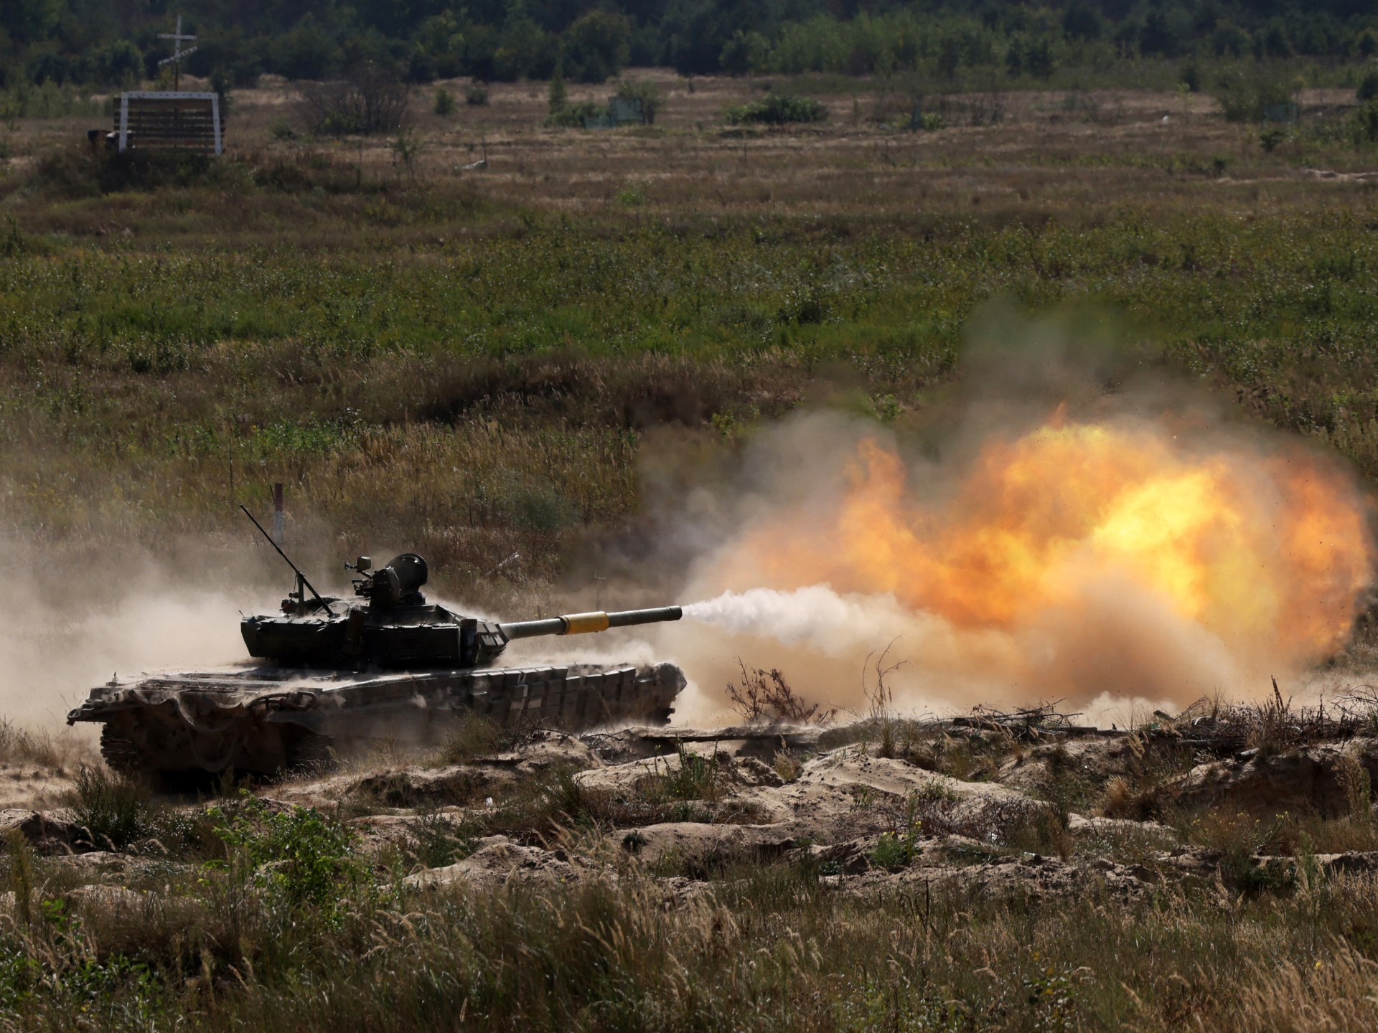
Research Report

Security Council

The Question of the Evolving Situation in Ukraine

Due to the ever-changing nature of the conflict, facts on the ground are likely to have evolved since the release of this report. Consequently, any statements pertaining to recent events are cited alongside the date updated on access if appropriate. However, delegates should note that debate will concern the most recent information available, and as such, should stay updated on the conflict between now and the conference.

Background Information
Vladimir Putin launched Russia’s full-scale military invasion into Ukraine on February 24, 2022, but armed conflict in the Donetsk and Luhansk regions of eastern Ukraine between Russian-backed forces and the Ukrainian military erupted years before in early 2014 following Russia’s annexation of Crimea in March that year. Since 2014 there have been various attempts to bring about an end to the violence including the Minsk Accords in 2015, which included a full ceasefire and the pull-out of heavy weapons and was signed by both Russia and Ukraine, though never fully implemented. ^{[1]}
By 2019, 7% of Ukraine’s territory (including Crimea) was under Russian occupation ^{[2]}, and between 2014 and early 2022, there were already 14,000 deaths^{[3]} and over 28,000 wounded in the conflict.^{[2]} However, since the rapid escalation of the conflict on February 24, 2022 through to September 24, 2023, the OHCHR recorded a further 27,449 civilian casualties in Ukraine: 9,701 killed and 17,748 injured.^{[4]} Further, in August 2023, US officials stated military casualties were nearing 500,000, with Russian deaths and injured troops dwarfing Ukrainian figures.^{[5]} In terms of territory, although Ukraine has recaptured, 54% of occupied territory in the year and half since Russia’s full-scale invasion, Russia still occupies 18% of the country.^{[1]}
In June 2023, Ukraine launched its much-anticipated counter-offensive in western Donetsk Oblast, including in the Bakhmut sector, and in western Zaporizhzhia Oblast.^{[6]} In late September, Ukraine brought heavy equipment beyond Russia’s first line of defences in the Zaporizhzhia region for the first time, making gains around the towns of Robotyne and Verbove. In the East, the Ukrainians have established total control over Bakhmut’s southern suburb of Klishchiivka after some of Russia’s most experienced troops were moved from the city to the Zaporizhzhia region but have been unable to make progress towards Bakhmut itself.^{[7]} However, from the end of September through to October, Russian ground attacks have increased in number.^{[8]} Some suggest this may be a trend that results in a wider Russian offensive, with UK intelligence describing the assault on Avdiivka, a town in the Donetsk region, as Russia’s ‘most significant offensive operation’ in Ukraine since at least January.^{[9]} However, it is thought that the main purpose of this attack aims to divert Ukrainian troops away from Kherson Oblast, where Ukrainian troops have been building up on the left bank of the Dnipro.^{[10]}

Issues
Although it may seem that there is little the United Nations can do to mitigate the effects of or even end the conflict, with the General Assembly lacking the authority to require any action from Member States and Russia holding veto on the Security Council, the UN-brokered Black Sea Grain Initiative signed on July 27, 2022 shows that mutually beneficial solutions can be agreed to by all sides.^{[11]} Despite the fact that Moscow pulled out of the Initiative in mid-July, arguing that Russia’s own agricultural exporters were being disadvantaged,^{[7]} the Initiative proves that negotiation can yield results, even if they are not permanently lasting. Vladimir Putin’s statement on October 18 that peace talks are ‘more likely’ after counteroffensive ‘failure’ ^{[12]} may also provide hope that diplomacy may yield results.
With the collapse of the Black Sea Grain Initiative, delegates may wish to use the conference to come to some agreement surrounding grain exports, or even attempt to renegotiate a similar deal to the one signed last year. As a conflict between wo major agricultural powers, the Russia-Ukraine war has led to global food insecurity. Particularly affected are those reliant on food imports, such as those in the Middle East and North Africa (MENA) region.^{[13]} Although some of the underlying reasons for the agricultural crisis, such as the labour shortages brought about by conscription, may be difficult to address, solutions or partial solutions may be found to other issues, such as Ukraine’s ability to export, and access to vital agricultural products such as fertilizers. For example, progress could be made curbing the drone attacks on Ukraine’s Danube ports.^{[7]}
Delegates may wish to address the treatment of prisoners of war (POWs). Since February 2022, both Ukrainian and Russian/separatist prisoners of war have suffered several forms of abuse.^{[14][15]} Although the Geneva Convention already describes the provisions that should be put in place in the treatment of POWs, agreements specific to the situation, including, through inspections and confirmations, conditional agreements, may help improve conditions for all POWs. Another issue that delegates could wish to address is the question of cluster munitions. Neither Russia nor Ukraine are signatories of the 2008 convention limiting the use of such weapons, and as such, they are used by both sides, though Russian use has been far more extensive than Ukrainian use.^{[16]} Agreement for both sides to stop using these weapons would be monumental, though perhaps unlikely.
Finally, some delegates may wish to attempt to do what so far, the UN has not been able to achieve: end the conflict. In this case, delegates may wish to review the Minsk Accords, why they failed and the solutions to their problems. Delegates should note that any resolution must have the approval of Russia, as a member of the P5. However, due to the veto power wielded by the United Kingdom, France and the United States of America, who are unlikely to pass any clauses that do not favour Ukraine, clauses cannot swing to far in Russia’s favour either. Accordingly, resolutions aimed at ending the conflict should look to achieve the stated objectives of both parties, which may include a complete withdrawal of Russian troops providing independence referenda are held in the self-proclaimed Donetsk and Luhansk People’s Republic. Through the principle of self-determination, most Member States would agree to the annexation of these regions if they were decided through truly democratic plebiscites. Therefore, if such legally binding referendums overseen by the UN as a trusted impartial actor took place, much progress may be made towards peace. Alternatively, delegates could look to the granting of autonomy or special tatus to Crimea and the regions of Donetsk and Luhansk as a more palatable solution to all parties. If both of these avenues for various reasons, demilitarization of varying degrees will produce outcomes of varying degrees: from an extension of the question of cluster munitions to include other weaponry, to the withdrawal of all military forces and international monitoring if not control over the disputed territory, demilitarisation is likely to be an enticing proposal for many.
Delegates should note that due to the high-level debate expected in Security Council, resolutions will be debated and voted on clause-by-clause. As such, if delegates wish to write resolutions founded the basis of accommodating terms, finding compromise on issues that satisfy both parties’ primary objectives, the dependent clauses, i.e., the clauses that benefit one country providing that a further clause benefiting the other country is also passed, should be written in one clause (utilising sub-clauses). Failing this, a veto concern is almost extremely likely to arise.

Countries Involved
Ukraine, Russia, The United Kingdom, The United States of America, China, India, France, Germany, China, Italy, All EU Member States, all ex-Soviet republics, either allied to Russia (e.g. Belarus) or at risk from future invasion should Ukraine set a precedent.

References
Overview of History of Conflict in Ukraine (Centre for Preventive Action) updated October 17, 2023: https://www.cfr.org/global-conflict-tracker/conflict/conflict-ukraine
Petro Porshenko, Seventy-third session of the General Assembly, 67th & 68th Meetings, February 20, 2019 (UN press release): https://press.un.org/en/2019/ga12122.doc.htm
Conflict in Ukraine’s Donbas: A Visual Explainer (Crisis Group): https://www.crisisgroup.org/content/conflict-ukraines-donbas-visual-explainer
Ukraine: civilian casualty update 24 September 2023 (United Nations Human Rights Office of the High Commissioner): https://www.ohchr.org/en/news/2023/09/ukraine-civilian-casualty-update-24-september-2023
Troop Deaths and Injuries in Ukraine War Near 500,00, U.S. Officials Say (New York Times): https://www.nytimes.com/2023/08/18/us/politics/ukraine-russia-war-casualties.html
Russian Offensive Campaign Assessment, June 8, 2023 (Institute for the Study of War): https://www.understandingwar.org/backgrounder/russian-offensive-campaign-assessment-june-8-2023
Ukraine in maps: Tracking the war with Russia (BBC News) updated September 29, 2023: https://www.bbc.co.uk/news/world-europe-60506682
Reported Russian ground attacks since March 2023 (Konrad Muzyka – Rochan Consulting): https://twitter.com/konrad_muzyka/status/1712028680707342828?s=20
Avdiivka: Why is the heavily defended Ukrainian town so important to Russia? (Forces.net): https://www.forces.net/ukraine/ukrainian-command-call-avdiivka-most-intense-attack-war
Frontline report: Ukraine gains bridgehead, reclaims two villages in Kherson Oblast on Dnipro (Euromaidan Press): https://euromaidanpress.com/2023/10/19/frontline-report-ukraine-gains-bridgehead-reclaims-two-villages-in-kherson-oblast-on-dnipro/
Black Sea grain exports deal ‘a beacon of hope’ amid Ukraine war – Guterres (UN press release): https://news.un.org/en/story/2022/07/1123062
Vladimir Putin: Ukraine peace talks are ‘more likely’ after counteroffensive ‘failure’ (Times Radio): https://www.youtube.com/watch?v=Q6FPFBcsqGY&t=2s
Impacts of the Russia-Ukraine War on Global Food Security: Towards More Sustainable and Resilient Food systems? (Tarek Ben Hassen and Hamid El Bilali—National Library of Medicine): https://www.ncbi.nlm.nih.gov/pmc/articles/PMC9368568/
What Is Happening To Ukrainian Prisoners Of War In Russia? (Forbes): https://www.forbes.com/sites/ewelinaochab/2023/10/21/what-is-happening-to-ukrainian-prisoners-of-war-in-russia/
Ukraine: Respect the Rights of Prisoners of War (Human Rights Watch): https://www.hrw.org/news/2022/03/16/ukraine-respect-rights-prisoners-war
Report: Russia uses cluster bombs ‘extensively’ (DW): https://www.dw.com/en/russia-uses-cluster-bombs-extensively-in-ukraine-report-says/a-62927491

Useful Links:
History of Conflict: good to have understanding: Mankoff, Jeffrey, writing for Centre for Strategic International Studies, April 2022: https://csis-website-prod.s3.amazonaws.com/s3fs-public/publication/220422_Mankoff_RussiaWar_Ukraine.pdf?tGhbfT.eyo9DdEsYZPaTWbTZUtGz9o2_
BBC News: https://www.bbc.co.uk/news/world-60525350
Interactive Map: https://storymaps.arcgis.com/stories/36a7f6a6f5a9448496de641cf64bd375

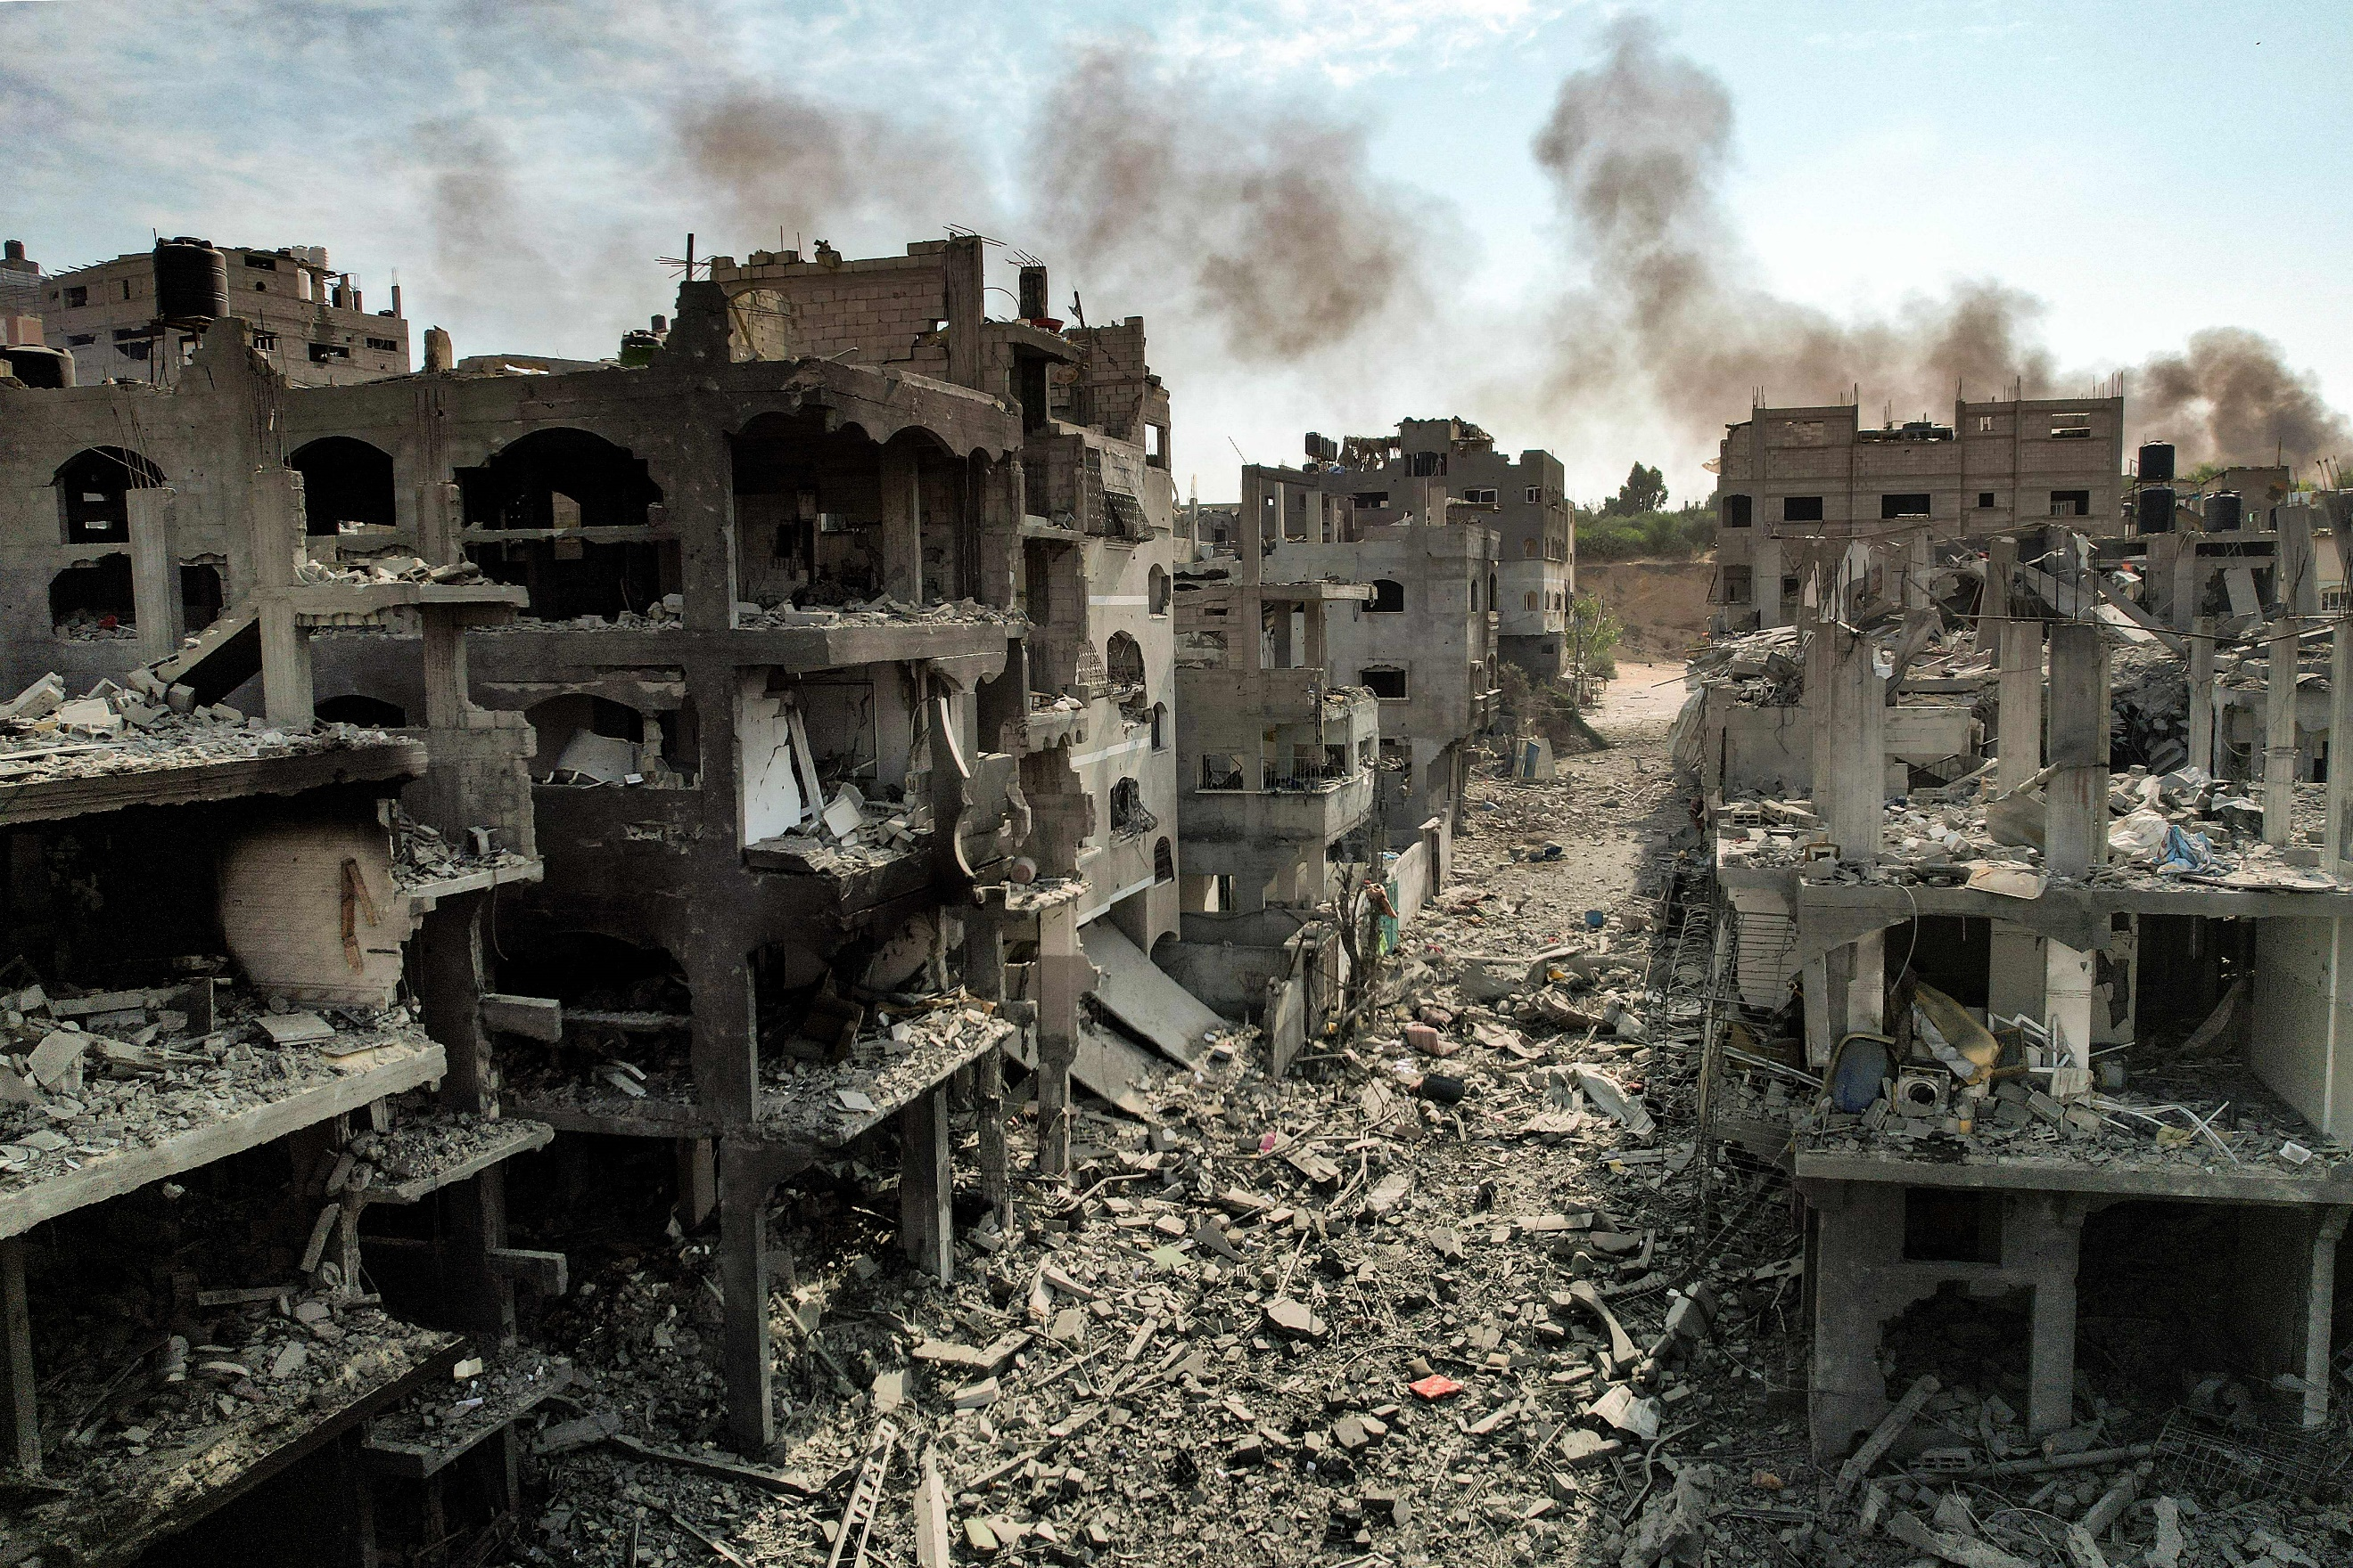
Research Report

Security Council

The Question of the Evolving Situation in Israel and the Palestinian Territories

Due to the very early days of the conflict in which this report was written, it is but a skeleton of the depth and research expected by delegates necessary to properly address this issue. Delegates should also note that while the focus may be on the recent conflict, resolutions aiming to find long-term solutions that address the problem more broadly may become the focus of debate.

Background Information
The Israeli-Palestinian conflict is one that predates the founding of the United Nations. The Jews occupied Palestine in Biblical times under the rule of ancient Rome, but were expelled in 70CE. In the centuries following, Palestine became an Arab/Muslim land, and was part of the Ottoman Empire until its collapse at the end of WW1. The territory came under British rule, with Jewish immigration in the 1920s and 1930s causing tensions to rise. In 1945, following WW2 and the horrors of the Holocaust, pressure increased on the British to take 100,000 Jewish settlers into Palestine. Britain refused, leading to a Jewish terrorist campaign. In 1947, Britian asked the Un to intervene, and Britian left in 1948.
The UN proposed the partition of Palestine, but when the day after the state of Israel was proclaimed on May 14, 1948, Iraq, Lebanon, Syria, Jordan and Egypt attacked Israel. Over the following years, tensions rose in the region: In 1967, the Six-Day War greatly increased Israel’s territory, and in 1973, Arab nations once again attacked Israel in the Yom Kippur War. Years of conflict were succeeded by what seemed to be years of progress, with the signing, first of the Camp David Accords between Israel and Egypt, then of the Oslo 1 and Oslo 11 Accords, which mediated the conflict and enabled mutual recognition between Israel and the newly established Palestinian Authority. This history of the conflict is immense, and this is but a brief, simplified summary—a deeper understanding of the conflict is advised.

Issues
Hamas is an Islamist militant group inspired by the Palestinian Muslim Brotherhood that took over the Gaza Strip after defeating longtime majority party Fatah in 2006. The USA and EU designate Hamas as a terrorist organisation due the armed resistance, including suicide bombing and rocket attacks, against Israel. On October 7, 2023, Israel declared war on Hamas following its surprise assault on southern Israel in the deadliest attack on the country for decades. This was followed by a directive from the defence minister to the Israeli Defence Forces (IDF) to carry out a “complete siege” of Gaza. Gaza is running out of water, fuel and supplies amid an Israeli aid blockade.
In the first two days of fighting alone, approximately 800 Israelis and 500 Palestinians were killed. Increasing loss of life is of primary concern in the conflict. However, escalation is also an enormous concern. Iran has a well-established patronage relationship with Hamas, and there are concerns that other groups with Iranian backing, most concerningly, Hezbollah, will be drawn into the war. Israel has already conducted cross-border operations into Lebanon, where Hezbollah is based.

Countries Involved
Israel, Palestine (UN observer state), Lebanon, Syria, Iran, Saudi Arabia, UAE, USA

Useful Links:
https://www.cfr.org/global-conflict-tracker/conflict/israeli-palestinian-conflict
https://www.cfr.org/backgrounder/what-hamas
https://www.bbc.co.uk/news/world-middle-east-54116567
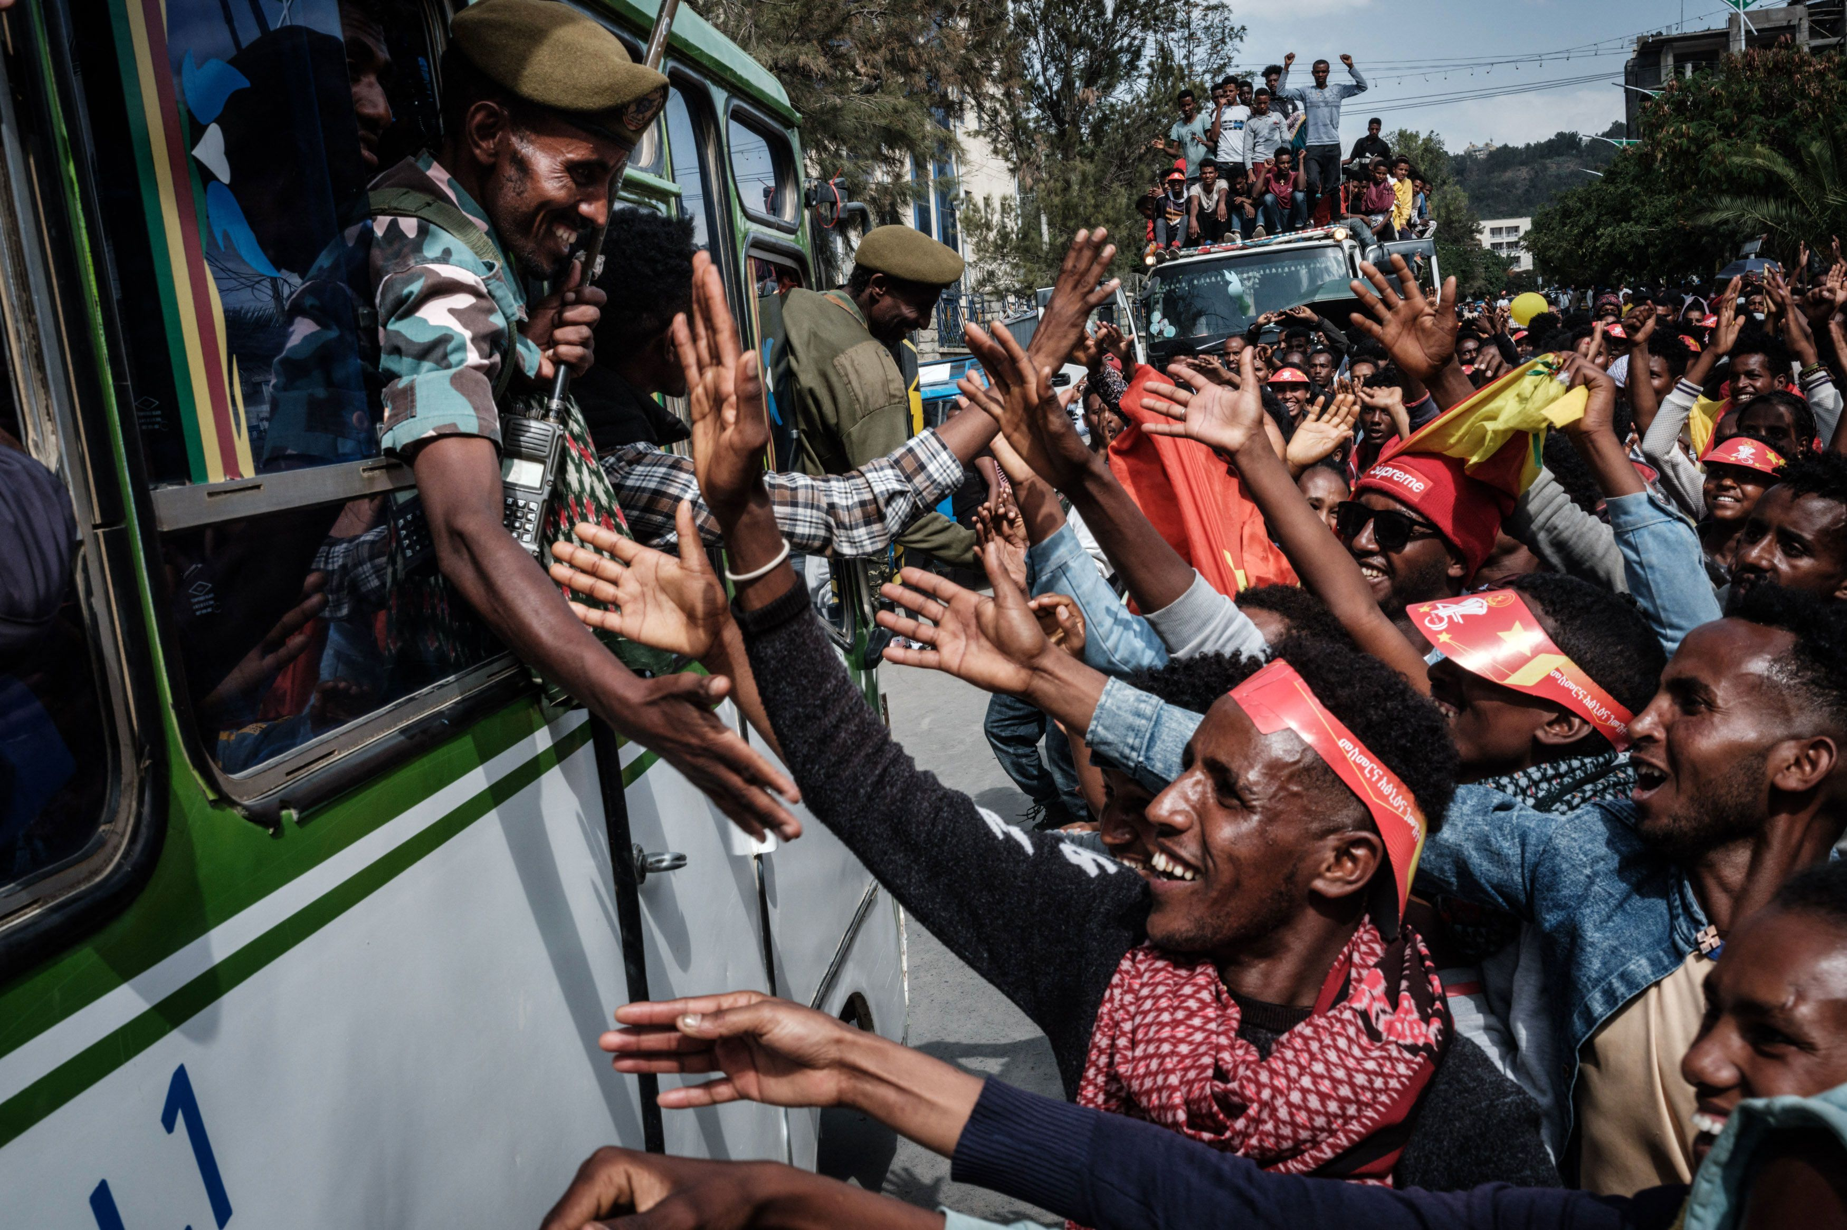
Research Report

Special, Political, and Decolonisation

The Question of the Conflict in Ethiopia

Background Information
The Ethiopian Conflict in Tigray, which began in November 2020 and has recently rebegun after an agreement to halt hostilities was endorsed by the TPLF and the Ethiopian central government on November 2, in Pretoria, South Africa. Throughout the conflict it has been a complex and multifaceted crisis that has gained much international attention.

Historical Context
Ethiopia's Federal System: Ethiopia has a long history of ethnic diversity and regional tensions. In 1991, after the fall of the Derg regime, the Ethiopian People's Revolutionary Democratic Front (EPRDF) established a federal system, granting significant autonomy to regional states. Tigray was one of these regional states, and its dominant political force was the Tigray People's Liberation Front (TPLF).
The EPRDF's Rule: The EPRDF, led by TPLF, governed Ethiopia for nearly three decades, overseeing both economic growth and authoritarianism. Its rule ended in 2018, when Abiy Ahmed, an Oromo, assumed the position of Prime Minister and initiated political reforms.

Causes of the Conflict
The conflict's roots can be traced back to political tensions and disputes between the TPLF and the federal government. These tensions were exacerbated by the federal government's push for centralized authority. Furthermore, Ethiopia's diverse ethnic makeup played a significant role in the conflict. As the TPLF tried to protect its regional interests, ethnic rivalries became more and more relevant. Finally, security concerned have also been a prevalent issue, the Ethiopian government claimed the TPLF attacked a federal military base in Tigray, prompting the military intervention. This was driven by security concerns and a desire to restore federal authority.

Recent developments
After a series of failed ceasefires, in September 2022, Tigrayan leadership committed to hold fire in order to participate in negotiations led by the AU after a series of failed ceasefires. A cessation of hostilities agreement was signed by the TPLF and Ethiopian central governmnet on November 2 in Pretoria, South Africa.
Despite some reduction in the Tigray conflict, ongoing tensions among regions and armed groups are challenging Abiy's efforts to unite Ethiopia. In 2022, Ethiopia arrested thousands in Amhara, fearing the growing power of a militia. They also failed to prevent attacks on Amhara people in Oromia and relocated residents near the Tigray border in Afar.
In 2023, violence has decreased, but challenges persist in implementing peace deals, including regional force integration and rebel negotiations. In April, Abiy faced protests and resistance when integrating regional forces. He also started peace talks with the Oromo Liberation Army, but by June, focus had shifted to eliminating paramilitaries to preserve national unity.
In the Amhara region, conflict flared as the federal government clashed with the Fano militia. The group, once an ally against Tigrayan forces, now accuses Addis Ababa of neglecting regional security. A senior official accused Fano of trying to overthrow the government, prompted by government's loss of control in some areas. Ethiopia declared a six-month state of emergency in Amhara to address the situation, with reports of gunfire and military aircraft.

Issues
The conflict has resulted in a severe humanitarian crisis, with millions of people in need of food, shelter, and medical assistance. Access to aid has been constrained due to ongoing violence, and in June 2023, USAID, and the World Food Programme (WFP) halted assistance efforts when they uncovered significant theft of food by Ethiopian soldiers and officials. This suspension resulted in numerous fatalities from starvation as humanitarian workers tried to adjust their food distribution methods.
Tens of thousands of people have been displaced, both internally, and as refugees in neighbouring countries. This has created a major refugee crisis. In 2023 there were more than four million internally displaced people.
There have been numerous allegations of human rights abuses, including massacres, sexual violence, and forced displacement, committed by both Ethiopian and Eritrean forces. In 2023, the UN requested four billion dollars to provide aid to twenty million people affected by conflict.
The conflict has implications for the political stability of Ethiopia and the broader Horn of Africa (Eastern Africa) region, with the potential for ethnic and regional conflicts to spread.

Countries Involved
Ethiopia, Neighbouring countries (Eritrea, Sudan and Kenya), USA (aid to Ethiopia), EU, UK, France, and all African Union Member States

Useful Links:
https://www.cfr.org/global-conflict-tracker/conflict/conflict-ethiopia
https://en.wikipedia.org/wiki/War_in_Amhara
https://www.wilsoncenter.org/blog-post/reflection-conflict-amhara-region-ethiopia

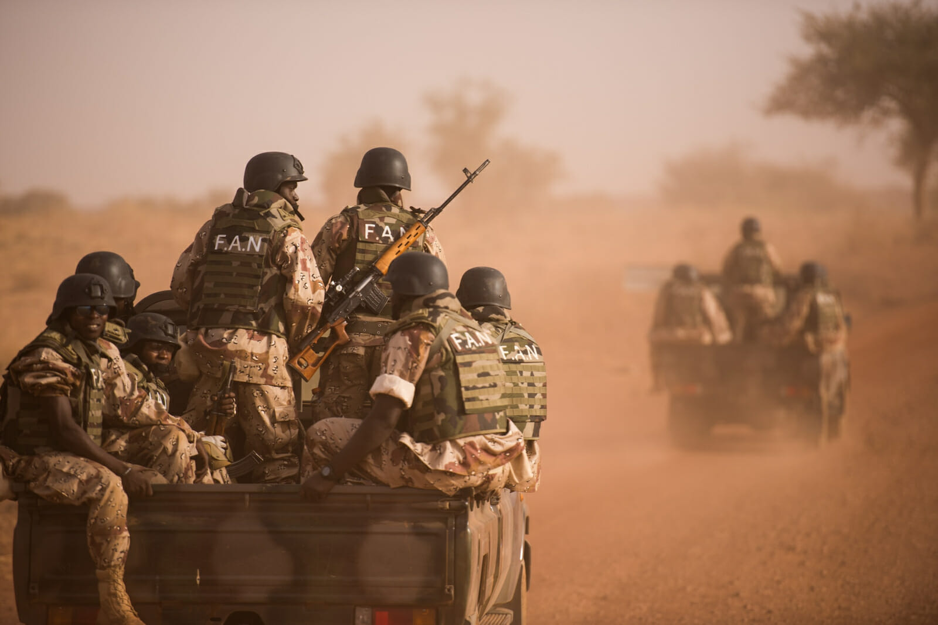
Research Report

Special, Political, and Decolonisation

The Question of Private Military Companies

Background Information
Private military companies, also known as PMCs, are private companies that provide military and security services. They often employ retired military personnel, but may also employ criminals from prisons, amongst others. Traditionally, they offer services such as armed combat, intelligence gathering, and logistical support. However, PMCs have been used by governments and organizations around the world for various purposes, including peacekeeping missions, security for infrastructure projects, and protection of high-profile individuals. Key terms and aspects to address regarding PMCs are mercenaries, security contractors, outsourcing, and rules of engagement. Several major nations play significant roles in the realm of private military companies. These nations include the United States, United Kingdom, Russia, China, and France. However, the involvement of these nations with PMCs varies in terms of regulations, policies, and oversight. Some countries have implemented stricter regulations, while others have a more noninterventionist approach. Perhaps the most well-known PMC is the Russian, state-funded Wagner Group, due to their prominent role in Ukraine, where they have been accused of immense human rights abuses.

Issues
While they can provide valuable services, they face several issues that raise concerns, majorly surrounding their accountability and potential for human rights abuses; they operate outside of traditional military structures and may not be subject to the same regulations and oversight, the lack of transparency making it difficult to hold them accountable for their actions. Another issue is the potential of conflict of interest. PMCs are profit-driven entities, and there is a risk that their financial interests could influence their decision-making. This can lead to questionable practises, such as prioritising profit over well-being of local populations or engaging in activities that may not align with the objectives of the mission or the best interests of the client. Lastly, the reliance on PMCs can raise questions about the role of the state in providing security. Some argue that outsourcing military and security functions to private entities undermines the state’s responsibility to protect its citizens and can erode public trust in government institutions. Addressing these issues requires increased transparency, regulation, and oversight of PMCs. It is crucial to establish clear guidelines, codes of conduct, and mechanisms for monitoring and accountability to ensure that PMCs operate in a manner that upholds human rights, international law, and the best interests of all parties involved.

Countries Involved
USA, UK, Russia, China, France, Ukraine, Sudan, and any country where PMCs operate

Useful Links:
https://ndupress.ndu.edu/Media/News/article/2031922/mercenaries-and-war-understanding-private-armies-today/
https://www.consilium.europa.eu/media/66700/private-military-companies-final-31-august.pdf
https://archive.globalpolicy.org/pmscs/50208-contractor-misconduct-and-abuse.html
https://civiliansinconflict.org/publications/policy/privatizing-war-the-impact-of-private-military-companies-on-the-protection-of-civilians/

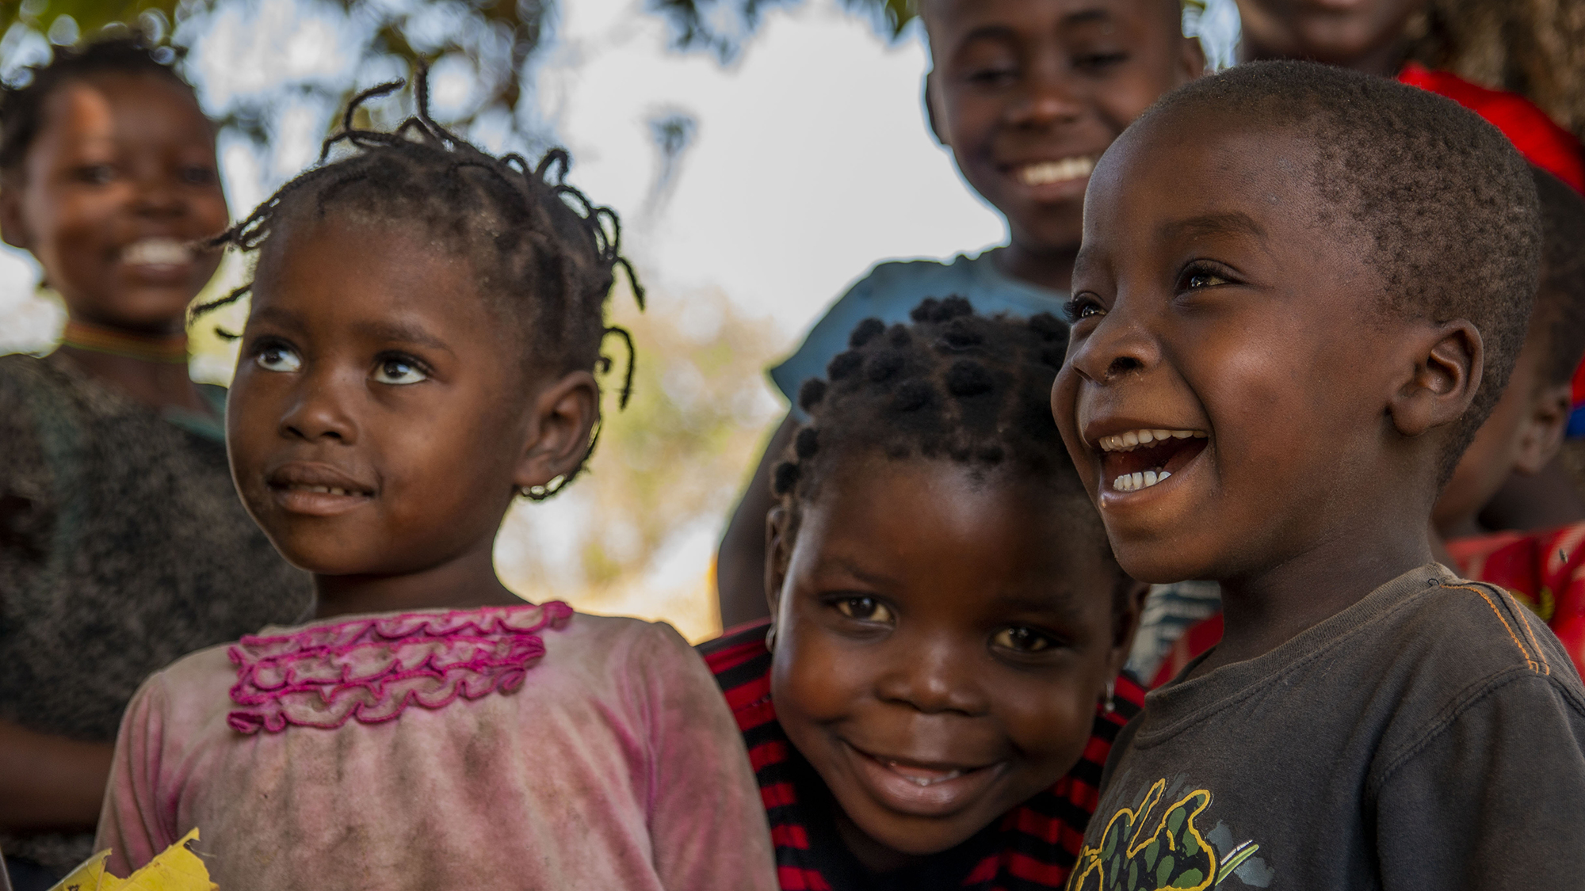
Research Report

United Nations Childrens Fund

Ensuring Children’s Health Through Improved Immunization

Background Information
Immunisation is key to achieving SDG 3, which aims to “ensure healthy lives and promote well-being for all at all ages” and therefore ‘we must do better’.
An estimated 67 million children missed out entirely or partially on routine immunization from 2019 to 2021. In Europe and Central Asia, this figure is 931,000 children.1 COVID-19 highlighted the overall weakness in health systems around the world and especially in rural or less developed areas and in particular weaknesses in the distribution of immunisation and in exacerbated the potential future problems on a global scale.
Despite successful immunisation against polio and smallpox and more recently immunisation against COVID-19, nations across the globe are in danger of outbreaks of vaccine-preventable diseases such as malaria and cholera as a result of climate change. New communities are being exposed to these diseases and do not have the vaccines, or skilled manpower to disseminate those vaccines. Additionally, vaccine misinformation is readily available through the huge range of social media platforms making it even harder for the uptake of immunisation when it is available. This will have a disastrous effect of economies especially if the future labour force is depleted through death or physical disability.
Covid -19 was a reminder that lack of immunisation in countries across the globe is not just a matter of infrastructure, instead it is a matter of political will. Until governments not only understand but also accept that SDG 3 is connected to all the other SDGs, this goal will never be met. The Covid-19 vaccination distribution should also be used as a reminder of the progress that can be made when global nations work together and when national and local organisations have the same focus and intended outcome.

Issues
Low socioeconomic areas have a prevalence of ZERO DOSE. This means that children in these areas will not receive any vaccinations while in Europe and Asia, there is a prevalence of UNDER-VACCINATED which means here some children receive some of the immunization. Low uptake in these areas is mainly due to misinformation and cultural hesitation.

Key Questions
Identifying ‘zero-dose’ and ‘under-vacinated’ areas
Identifying ways to address the inequitaies in these areas identified above
Developing better ways to record individual child-health systems
Developing infrastructure to ensure availability and distribution of vaccines especially on areas of inequity
Improving communication and confidence in vaccines increase the uptake.
Investing in primary health
Improving donor support

Countries Involved
India, Pakistan, Ukraine, Nigeria, Ukraine, United States, France, Israel

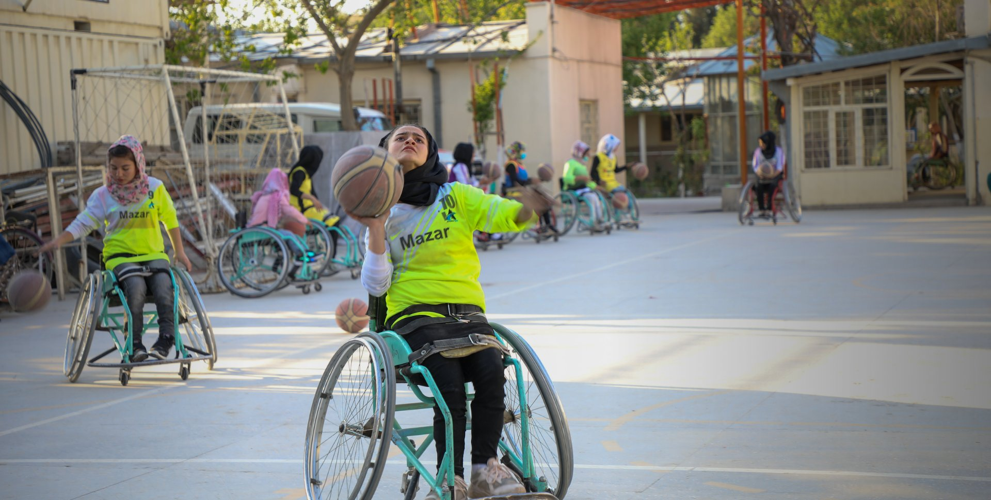
Research Report

United Nations Childrens Fund

Ensuring all Children, Including those with Disabilities, Live in Barrier-Free and Inclusive Communities

Background Information
There are 240 million children with disabilities in the world. It is important that these children are given the same opportunities as abled children. Policymakers need to ensure that teachers are trained to teach children with disabilities in the same classrooms and same schools. Treating all children equally, regardless if their disability will create inclusive communities and enrich every child’s life by exposing them to diverse backgrounds.
Providing the correct environment for children includes ensuring that buildings adequate support children with disabilities providing them with opportunities to develop independence. Learning material should also be provided to allow all children to access information and resources.
Furthermore, providing stigma free environments is essential for children to thrive. Children should be able to live in barrier-free communities. According to Article 14, children have the right to freedom of thought, conscience, and religion. In Article 16, makes it clear that providing barrier-free lives for children means children should be protected against ‘unlawful attacks on his or her honour and reputation’.

Key Questions
How can children with disabilities or in minority groups be empowered not only reach their full potential but also to seek justice.
Raising awareness in all communities to promote equality amongst all children.
Identifying ways to level the playing field for all children.
Ensuring that global nations are held accountable if children are not able to live in barrier-free communities.
Countries Involved
Kenya, Bulgaria, Montenegro, India, United Kingdom, United States of America, Albania

Useful Links:
UNICEF Disability Inclusion Policy and Strategy: 2022-2030
file (unicef.org)
Protecting children and adolescents with disabilities from the pandemic | UNICEF Europe and Central Asia

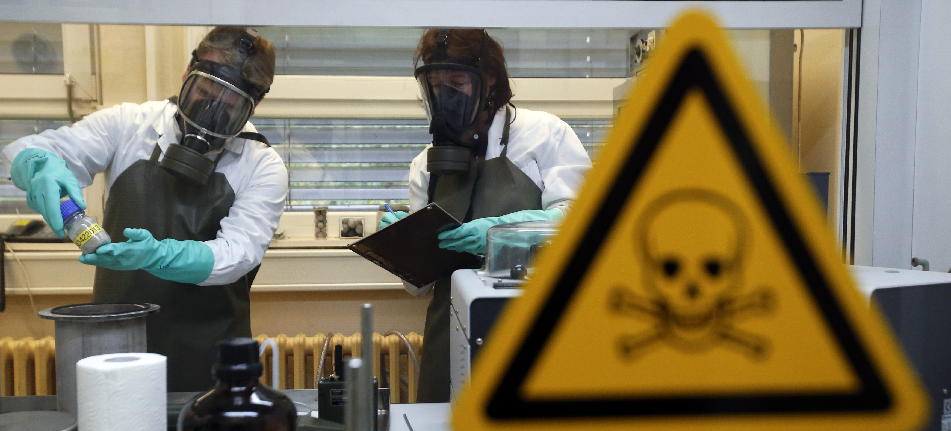
Research Report

World Health Organisation

The Question of Bioweapons

Background Information
The biological weapons convention entered into force on the 26th of March 1975, it prohibited the use of biological and toxin weapons. Despite this there remains an active threat from these devices, particularly if they were to be obtained by terrorist organisations or other non-state actors.
Diseases have been utilised in warfare by humans for centuries, with prominent examples being the proposed use of smallpox infected blankets in North America by the British during wars with various native American groups as well as the Mongols catapulting plague ridden bodies over castle walls during a siege in 1347.
However, in the modern period and with our more nuanced understanding of virology these weapons pose far more of a threat. Despite the signing of the 1925 Geneva protocol (which much like the biological weapons convention banned the use of biological weapons) biological weapons continued to be used and tested going into World War 2.
The biological weapons convention does seem to have limited the dissemination of biological weapons somewhat, however, there are still some countries accused of storing biological weapons although this has not been definitively proven.
A more pressing concern in the modern era is the use of biological weapons by terrorist organisations. The issue of biological weapons by terrorist groups is a somewhat modern phenomenon, examples include the Tokyo subway anthrax attack as well as the “anthrax letters” sent to some US politicians.
So far major death tolls have been avoided, mainly due to errors on the part of the terrorist groups in the making of their weapons. As information disseminates on the internet however it will only become easier for terrorist groups to obtain deadly biological weapons, unlike the amateurish creations that have been used before.
One significant fear is the possibility of bioweapons being captured by terrorist groups from countries with (Alleged) stockpiles. Little can be done about this without international cooperation as many nations will not submit to inspection as a matter of policy.
Bioweapons and the treat they pose can also be looked at from a “lab leak” perspective. Despite lacking conclusive evidence either way there remains suspicions that the Covid – 19 pandemic was the result of a leak (or even deliberate release) from the Wuhan virology institute. China denies such claims and they are mostly relegated to the level of conspiracy theorists, but the theory has been gaining traction over the last few months. Some argue that there needs to be more universal and stronger safety standards in biological testing institutes to ensure that there is no risk of a “lab leak” that could kill huge amounts of people.
The issue of bioweapons is a complicated one largely due to the secrecy of many of the nations involved. Some will not undergo UN inspection under any circumstances. Is it possible to strike some sort of deal with these countries? What can be done to ensure bioweapons do not fall into terrorist hands? Can the global community trust China when it says that it knows for certain that Covid 19 was not the result of a lab leak. These are the questions that must be answered if the issue of bioweapons is to be in any way resolved.

Useful Links:
https://libraryresources.unog.ch/bioweapons/undocs
https://www.who.int/health-topics/biological-weapons#tab=tab_1
https://www.nti.org/education-center/treaties-and-regimes/convention-prohibition-development-production-and-stockpiling-bacteriological-biological-and-toxin-weapons-btwc/
https://www.ncbi.nlm.nih.gov/pmc/articles/PMC1326439/

Research Report

World Health Organisation

The Question of Medical Misinformation

Background Information
In the wake of the Covid – 19 pandemic medical misinformation and issues such as vaccine hesitancy have become more pressing matters. Previously being “anti vax” was seen as a fringe and conspiratorial position. Now however, it has entered the political mainstream (especially regarding the Covid vaccine). This doesn’t just have negative impacts on trust in medical institutions, it objectively results in more deaths and lowered herd immunity. Bringing back trust in these systems is no easy task and studies have shown then when shown real information that should convince them the other way many people only become more steadfast in their beliefs.
It is for this reason that traditional methods of de – radicalisation will not work on a large scale. Once someone is radicalized and inducted into the conspiracy it is arguably to late to save them. Some have argued that preventative measures should be taken to shut down those who perpetrate these controversial beliefs. But can this be done without infringing upon their freedom of speech? If not, is it still worth it?
It is not just non state actors who are to blame. Some governments and senior politicians in those governments have promoted medical misinformation and spoken against the accepted science. This is especially prevalent in populist politicians who attempt to spread doubt about the efficacy of vaccines in service of a political agenda.
Medical misinformation can have concrete medical consequences. Widespread vaccine use is required to ensure herd immunity among a population to a given virus. If this is not achieved the virus will be able to stay much longer than previously possible, multiplying the death counts exponentially. Some argue that this means vaccine use should not necessarily be a solely personal choice, it is one that affects the whole population and can cause harm outside of just the person taking the extra risk.
Some people are concerned, however, that in supressing medical misinformation there is a potential danger to free speech. In many countries it is a legal right to promote false or misleading information. Some social media companies took it upon themselves to try and limit misinformation on their websites, utilizing their terms of service that allow them to ban certain figures for almost any reason. The effectiveness of these measures has been debatable and some believe it sets a dangerous precedent about how companies will be able to limit the voice those with certain views have on their website, especially if the same logic is used in the future against genuine human rights organizations. The ability for governments to force social media companies to supress certain views may be useful in the short term but the long term consequences of such a move could be dire.
Medical misinformation is not an issue that can be sold per se and is particularly difficult to deal with in developing countries. Potential “Solutions” are either limited in effectiveness or could threaten the institutions and liberty of the countries that utilise them. The committee must consider whether this is worth the risk and whether those perpetrating the information should be held liable for the damage that results from their speech.

Useful Links:
https://www.un.org/en/coronavirus/access-information-cure-disinformation
https://www.un.org/en/battling-covid-19-misinformation-hands
https://www.un.org/en/countering-disinformation
https://www.ncbi.nlm.nih.gov/books/NBK572169/

Rules of Procedure

Expectations of Delegates

During debate, each delegate is expected to

- respect the decisions of the Chair at all times,
- obtain the floor before speaking,
- stand when speaking,
- use courteous and formal language at all times,
- try to avoid using the pronoun “I”, they should instead refer to themselves as “the delegation of Russia” or “We, The Russian Federation believe...”

Roll Call
The chair will begin with a roll call. When they read out the name of your country, delegates are expected to answer with either present or present and voting.

Present: the delegate is ready to begin debate, but wants to have the option to abstain during substantive votes (voting on amendments or resolutions).

Present and voting: the delegate does not wish to have the option to abstain on substantive votes (votes on resolutions or amendments). This option is more restrictive, but good for sending a strong message if your country has a clear stance on the topic.

Opening speeches

Delegates will be encouraged to give an opening policy statement regarding their countries stance on the topic being discussed. Opening policy statements will generally be limited to 1 minute in length, and delegates should yield the floor to the chair when finished.

Lobbying

Lobbying is an informal period of free discussion in which delegates may move around and speech to others about the topic at hand. Lobbying time should be used to discuss resolutions. Delegates who have submitted a resolution should aim to get signatories for their resolution, and other delegates should think about constructing amendments to submit to the chair.

Debating a resolution

Once the period of lobbying has elapsed, the chair will move the committee into debate on a resolution. The submitter of the resolution will be invited to read out their operative clauses. The committee will then move into open debate on the resolution, the chair will set the length of time for this. Delegates will be invited to give speeches regarding the resolution, starting with the delegate who submitted it.

Debating an amendment

Amendments may be submitted to the chair at any time. We will provide instructions of how to submit amendments electronically closer to the time of the conference.

Once the period of debate on the resolution has elapsed, the chair will move the committee into debate on specific amendments. The submitter of the amendment will be invited to read it out. The committee will then move into closed debate on the amendment, the chair will set the length of time for this. Delegates will be invited to give speeches for and against the amendment, starting with the delegate who submitted it.

Changing debate time

Depending on how the debate is progressing, the chair may choose to extend or reduce debate time on a resolution or clause.

If a delegate wishes the debate time to be changed, they must wait until no delegate is giving a speech. They should then raise their placard and, when recognised by the chair “motion to extend debate time by x minutes” / “motion to reduce debate time by x minutes” / “motion to move to voting procedure on this amendment “

Voting procedure

Before voting on a resolution, the chair may choose to move into a period of closed debate in which delegates speak for or against a resolution.

When voting on a resolution or amendment, the chair will ask you to raise your placard at an appropriate time. You must cast a vote, either for, against or abstaining. However, you may not abstain if you registered “present and voting” at the start of the committee.

Yielding

During open speeches, delegates may yield their time to the chair or another country or to Points of information
Would it be in order to yield to country X
I yield my time to the chair

During debate, delegates will be allowed to yield their remaining time to the chair, to points of information (questions from other delegates) or to another delegate. The maximum length of a yield chain permitted is one.

Points
Delegates may raise the following points to the chair during debate. Delegates must raise their placard, and wait to be recognised by the chair before stating their point. Points may not interrupt a speaker, unless they are a point of personal privilege regarding audibility of a speaker.

A Point of Personal Privilege refers to the well being of a delegate. It may not refer to the resolution. It may only interrupt a speaker if the speech is inaudible. This is the only point that may interrupt a speaker.

A Point of Information is a question regarding a speech. It may only be asked once a delegate has yielded to points of information and the chair has called upon you.

A Point of Order is used to indicate an instance of improper parliamentary procedure.This includes if you think a delegate has not followed the correct procedure, or if you think the chair has made a mistake eg debate time has elapsed and they haven’t noticed.

A Point of Parliamentary Enquiry is a question to the Chair about the rules of procedure. For example, if you’re unsure of how to submit an amendment.

Resolution Guide
A resolution is a document that seeks to solve the problems that a committee addresses. We encourage delegates to consider writing a resolution on one of the topics of their committee. Writing a resolution will aid a delegate’s understanding and knowledge of the topic and of Model UN, and allow them to get the most out of the conference. Delegates should email their resolution to the chairs before the start of their committee session so that it can be distributed before lobbying. After a period of lobbying, the resolution with the most signatories will be chosen for debate.

Introduction

The first section of a resolution is the introduction. For Lingfield MUN, the layout should be as follows:

Committee: [insert committee name]
Topic: [INSERT TOPIC]
Sponsor: [INSERT YOUR COUNTRY]
Signatories: [INSERT YOUR CO-SUBMITTERS COUNTRY NAMES]

Preambulatory clauses
Your preambulatory clauses come after the introduction. They should set out things which should be known before starting debate. For example, they may contain definitions, background information, statistics and remind delegates of previous resolutions passed by the UN.
A preambulatory phrase is the word or phrase which goes at the beginning of the clause. Each preambulatory clause should begin with one of the below phrases:

Affirming  Alarmed by  Approving  Aware of  Bearing in mind  Believing  Confident  Contemplating  Convinced  Declaring  Deeply concerned  Deeply conscious  Deeply disturbed  Deeply Regretting  Desiring  Emphasising  Expecting | Expressing its appreciation Expressing its satisfaction Fulfilling  Fully alarmed  Fully aware Fully believing Further deploring  Further recalling  Guided by  Having adopted  Having considered  Having considered further Having devoted attention Having examined  Having received  Having studied  Keeping in mind  Noting | Noting further  Noting with deep concern Noting with satisfaction  Noting with approval  Noting with regret  Observing  Reaffirming  Realising  Recalling  Recognising  Referring  Seeking  Taking into account  Taking into consideration Taking note  Viewing with appreciation Welcoming

The preambulatory phrases should be italicized and each clause should end with a comma. An example is shown below:

Noting with deep concern that more than 100 humanitarian aid workers have died in South Sudan since the most recent conflict erupted in 2013,

Operative Clauses
Operative clauses should go underneath your preambulatory clauses. They should describe what you want to achieve in the resolution and how you plan to solve the issue at hand. This is where most (if not all) of the debate should take place.
An operative phrase is the word or phrase which goes at the beginning of the clause. Each operative clause should begin with one of the below phrases:

Accepts  Affirms  Approves  Asks  Authorises  Calls for  Calls upon  Confirms  Congratulates  Considers  Declares accordingly Deplores  Designates | Draws attention to  Emphasises  Encourages  Endorses  Expresses its appreciation Expresses its hope  Further invites  Further proclaims  Further reminds  Further recommends Further requests  Proclaims | Reaffirms  Recommends  Regrets  Reminds  Requests  Solemnly affirms  Strongly encourages  Strongly requests  Strongly urges  Supports  Trusts  Urges

Security council only: Condemns, Demands, Instructs, Strongly condemns
Each clause should be numbered, and the operative phrase should be underlined. Each clause should end with a semicolon, except for the final clause which should end with a full stop. You can have sub-clauses (ordered with letters) and sub-sub-clauses (numbered with Roman numerals) but you cannot go any further. Sub-clauses do not need to start with an operative phrase.
Advice: Usually including more details in an operative clause will make it stronger or at least make the idea more clear to other delegates. A simple way to strengthen each operative clause is to answer the “who, what, when, where, why, and how” of each action you’re calling for. These details can be broken down into sub-clauses underneath the main operative clause.

An example of an operative clause is shown below:

1. Endorses the construction of infrastructure, specifically transport infrastructure, for the purpose of increasing trade links and economic growth in the region, this infrastructure would:
- Be built both within South Sudan and between South Sudan and the surrounding areas,
- Be funded and overseen by the United Nations Industrial Development Organization,
- Employ labourers from local areas wherever possible;

Glossary
Abstain: During a vote on a substantive matter, delegates may abstain rather than vote yes or no. This generally signals that a country does not support the resolution being voted on, but does not oppose it enough to vote no. This option is only available if the delegate registered as “present” and not “present and voting” during roll call.
Amendment: A change to a draft resolution on the floor. Can be of two types: a “friendly amendment” is supported by the original draft resolution’s sponsors, while an “unfriendly amendment” is not supported by the original sponsors and must be voted on by the committee as a whole.
Bloc: A group of countries in a similar geographical region or with a similar opinion on a particular topic. Blocs typically vote together and may collaborate on producing amendments during lobbying.
Chair: A member of the dais that moderates debate, keeps time, rules on points and motions, and enforces the rules of procedure.
Member State: A country that has ratified the Charter of the United Nations and whose application to join has been accepted by the General Assembly and Security Council. Currently, there are 193 member states.
Motion: A request made by a delegate that the committee as a whole do something. In LCMUN, delegates can motion to extend debate time or move to voting procedure.
Placard: A piece of cardstock with a country’s name on it that a delegate raises in the air to signal to the Chair that he or she wishes to speak.
Point: A request raised by a delegate for information or for an action relating to that delegate. Examples include a point of order, a point of information, and a point of personal privilege.
Procedural: Having to do with the way a committee is run, as opposed to the topic being discussed. All delegates present must vote on procedural matters and may not abstain.
Roll Call: The first order of business in a Model UN committee, during which the Chair reads aloud the names of each member state in the committee.
Rules of Procedure: The rules by which a Model UN committee is run.
Second: To agree with a motion being proposed. Motions must be seconded before they can be brought to a vote. Delegates can second a motion by raising their placards when the chair asks for seconds.
Signatory: A country that wishes a draft resolution to be put on the floor and signs the draft resolution to accomplish this. A signatory need not support a resolution; it only wants it to be discussed. In LCMUN, the resolutions and amendments with the most signatories will be discussed first.
Sponsor: The delegate(s) who wrote a draft resolution.
Substantive: Having to do with the topic being discussed. A substantive vote is a vote on a draft resolution or amendment already on the floor.
Veto: The ability, held by China, France, the Russian Federation, the United Kingdom, and the United States to prevent any draft resolution or amendment in the Security Council.

