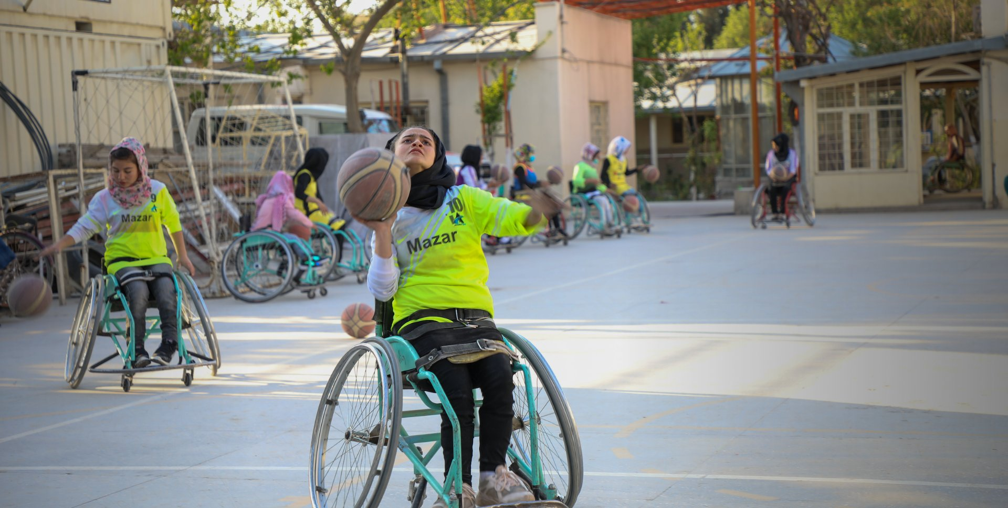
Research Report

United Nations Childrens Fund

Ensuring all Children, Including those with Disabilities, Live in Barrier-Free and Inclusive Communities

Background Information
There are 240 million children with disabilities in the world. It is important that these children are given the same opportunities as abled children. Policymakers need to ensure that teachers are trained to teach children with disabilities in the same classrooms and same schools. Treating all children equally, regardless if their disability will create inclusive communities and enrich every child’s life by exposing them to diverse backgrounds.
Providing the correct environment for children includes ensuring that buildings adequate support children with disabilities providing them with opportunities to develop independence. Learning material should also be provided to allow all children to access information and resources.
Furthermore, providing stigma free environments is essential for children to thrive. Children should be able to live in barrier-free communities. According to Article 14, children have the right to freedom of thought, conscience, and religion. In Article 16, makes it clear that providing barrier-free lives for children means children should be protected against ‘unlawful attacks on his or her honour and reputation’.

Key Questions
How can children with disabilities or in minority groups be empowered not only reach their full potential but also to seek justice.
Raising awareness in all communities to promote equality amongst all children.
Identifying ways to level the playing field for all children.
Ensuring that global nations are held accountable if children are not able to live in barrier-free communities.

Countries Involved
Kenya, Bulgaria, Montenegro, India, United Kingdom, United States of America, Albania

Useful Links:
UNICEF Disability Inclusion Policy and Strategy: 2022-2030
file (unicef.org)
Protecting children and adolescents with disabilities from the pandemic | UNICEF Europe and Central Asia

