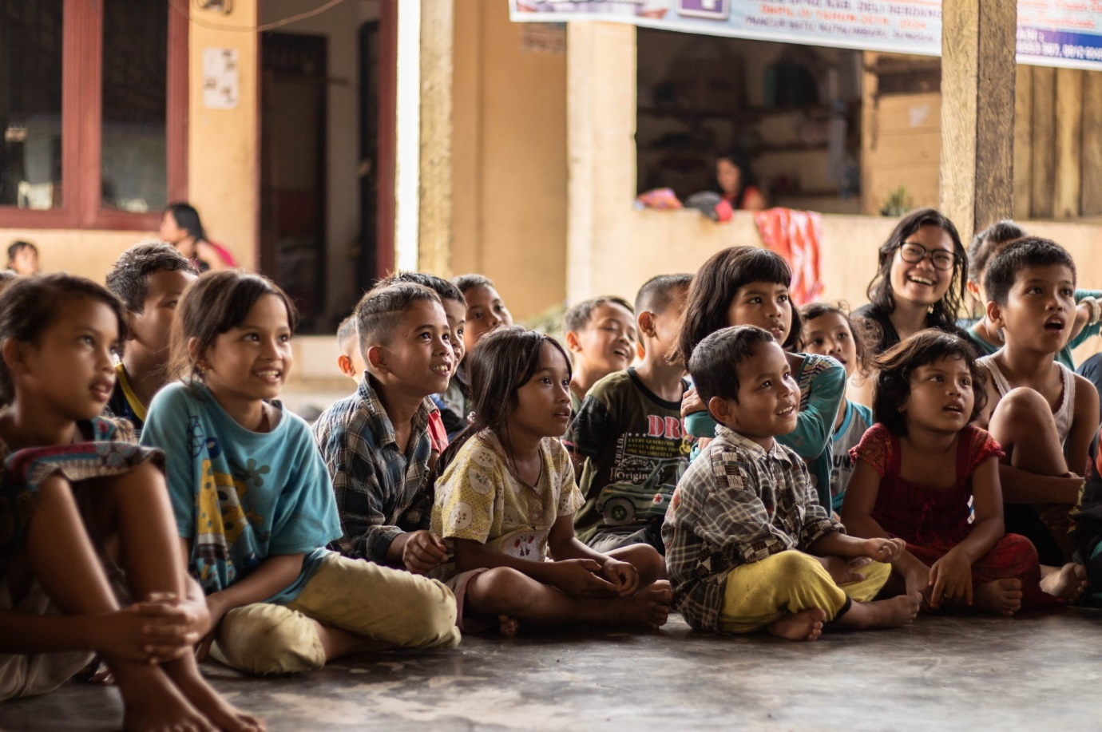
Research Report

Disarmament and International Security

The Question of Modern Slavery and People Trafficking in Africa and The Middle East

Background Information
In the last four decades, slavery and people trafficking have exploded across the Middle East, with countries such as Saudi Arabia and Qatar using the people trafficking of migrant workers from poorer countries in large numbers as slave labour for construction projects. The UN recognises the importance of tackling this issue directly, as and I nothing is done, it fears that this increase in people trafficking could reach levels as high as 50 million people in the coming decade.

Issues
Saudi Arabia has an estimated 740,000 people living in modern slavery. This is due to its policy of importing migrant workers and stripping them of their passports, effectively trapping them in the country to work for extremely low pay—crippling them in poverty.
An estimated 3.8 million people in Africa are in forced labour. Countries with the highest levels of modern slavery included Eritrea, Mauritania, and South Sudan. Often, as is the case in Mauritania, slavery exists along ethnic boundaries. Over 200,000 people have been trafficked to the Middle East over the past two decades, with Yemen and the United Arab Emirates having amongst the highest human trafficking levels.

Key Questions
Delegates should consider whether countries in Middle East and Africa are taking sufficient action to prevent human trafficking in their countries or actively encouraging the process.
Delegates should consider agreements that could be put in place to curb modern slavery and people trafficking within Africa and the Middle East.
Delegate not representing countries in either region should recognize the importance that stopping human trafficking and modern day slavery plays on the international stage, and therefore work hard to curb its prevalence everywhere.

Countries Involved
Saudi Arabia, Qatar, UAE, Eritrea, Mauritania, South Sudan, USA, UK, France, and Yemen.

Useful Links
https://www.walkfree.org/global-slavery-index/country-studies/saudi-arabia/
https://en.m.wikipedia.org/wiki/Human_trafficking_in_the_Middle_East#:~:text=In%20the%20Middle%20East%2C%20some,camel%20jockeying%20of%20young%20boys

