Dear Parents

Lingfield College uses the SOCS Programme run by SchoolsSports.com. This programme provides a focal point for all our matches and a platform for staff to manage sport efficiently and communicate with players and parents more effectively. It is important to note that this system is used by all the schools we compete against across a plethora of activities.

On our SOCS web page https://www.lingfieldcollegesport.co.uk/ you can explore the fixtures which will be taking place, see featured schools which use SOCS, read latest news, results and the team sheets for that specific week.

So how does this whole system work and what do you need to do?
- First of all, save Lingfield SOCS Short Cut to your phone.
• The list of fixtures for the week ahead will be sent out every Friday via SchoolPost.
• Students are informed they will be playing in the relevant fixtures and will also see the team sheets on
the information screen in the Sports Hall and Main School Corridor.

• The team sheets for that week of fixtures go live at least 48 hours before the specific fixture. It will be
up to you, and your child, to check on SOCS to confirm what team they are playing in as well as all the
other necessary details. For data protection, team sheets are password protected. The password is
LingfieldCollege (please note this is case sensitive).

We would encourage both you and your child to ensure that SOCS is saved to your mobile phones as soon as possible. Once saved, you will see how efficient it is and how beneficial it is to our ever-increasing fixtures programme. If you have any SOCS queries, please contact Mrs Lewis at lewiss@lingfieldcollege.co.uk.

Kind regards

Mr S Casey
Director of Sport and Co-curricular Activities

Sport shortcut instructions for iPhone

- Go to www.lingfieldcollege.co.uk

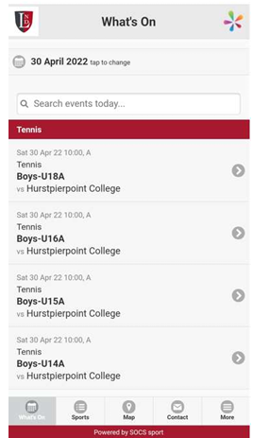
- Tap the Share icon


- Tap Add to Home Screen
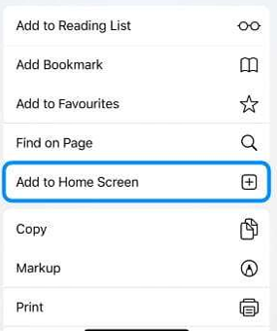

4. A window will then appear showing the name, icon and URL (tap the name if you would like to edit it).
5. Tap add, and the icon will be added to your home screen.

