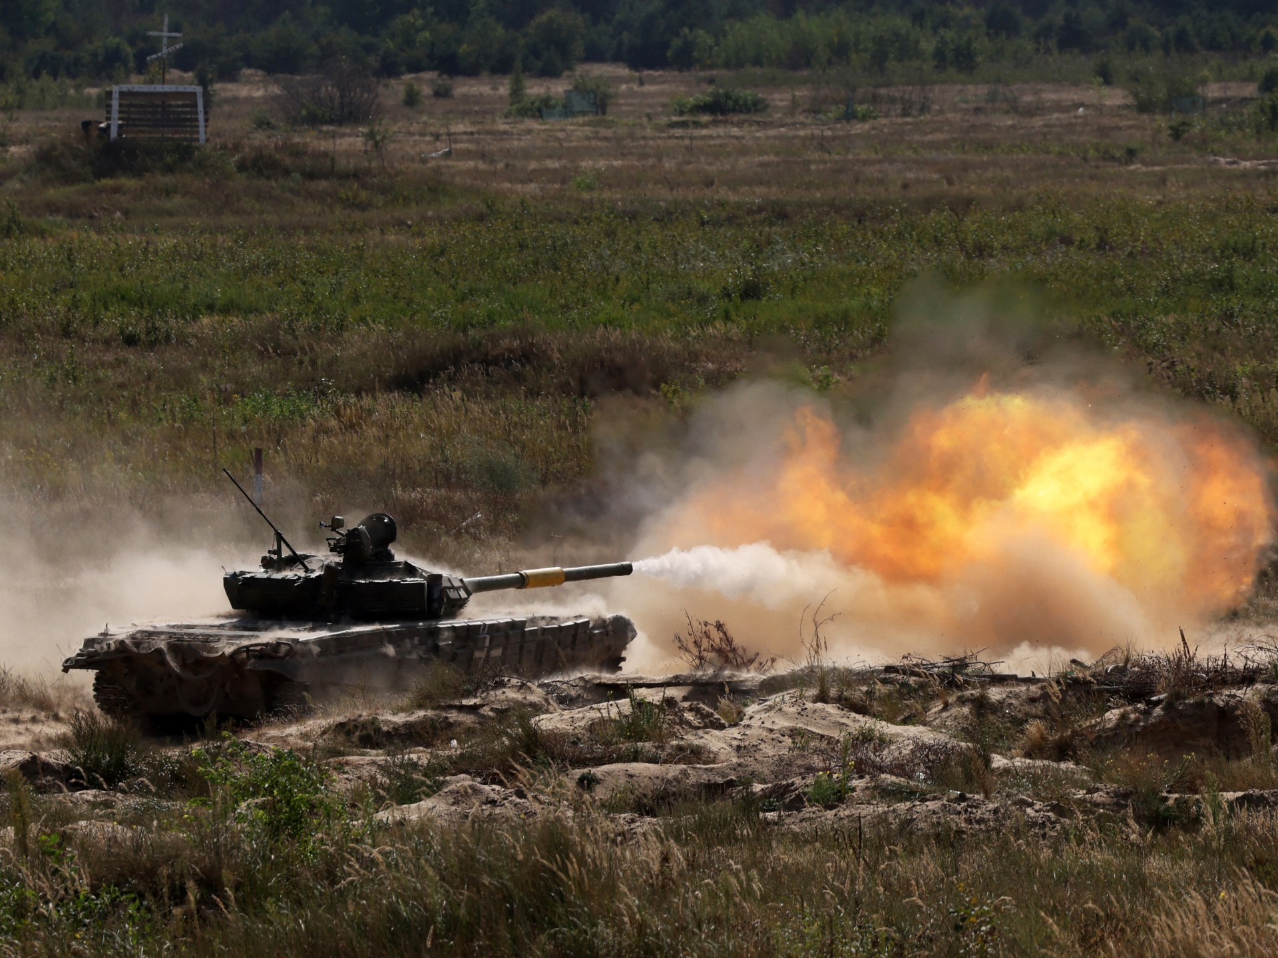
Research Report

Security Council

The Question of the Evolving Situation in Ukraine

Due to the ever-changing nature of the conflict, facts on the ground are likely to have evolved since the release of this report. Consequently, any statements pertaining to recent events are cited alongside the date updated on access if appropriate. However, delegates should note that debate will concern the most recent information available, and as such, should stay updated on the conflict between now and the conference.

Background Information
Vladimir Putin launched Russia’s full-scale military invasion into Ukraine on February 24, 2022, but armed conflict in the Donetsk and Luhansk regions of eastern Ukraine between Russian-backed forces and the Ukrainian military erupted years before in early 2014 following Russia’s annexation of Crimea in March that year. Since 2014 there have been various attempts to bring about an end to the violence including the Minsk Accords in 2015, which included a full ceasefire and the pull-out of heavy weapons and was signed by both Russia and Ukraine, though never fully implemented. ^{[1]}
By 2019, 7% of Ukraine’s territory (including Crimea) was under Russian occupation ^{[2]}, and between 2014 and early 2022, there were already 14,000 deaths^{[3]} and over 28,000 wounded in the conflict.^{[2]} However, since the rapid escalation of the conflict on February 24, 2022 through to September 24, 2023, the OHCHR recorded a further 27,449 civilian casualties in Ukraine: 9,701 killed and 17,748 injured.^{[4]} Further, in August 2023, US officials stated military casualties were nearing 500,000, with Russian deaths and injured troops dwarfing Ukrainian figures.^{[5]} In terms of territory, although Ukraine has recaptured, 54% of occupied territory in the year and half since Russia’s full-scale invasion, Russia still occupies 18% of the country.^{[1]}
In June 2023, Ukraine launched its much-anticipated counter-offensive in western Donetsk Oblast, including in the Bakhmut sector, and in western Zaporizhzhia Oblast.^{[6]} In late September, Ukraine brought heavy equipment beyond Russia’s first line of defences in the Zaporizhzhia region for the first time, making gains around the towns of Robotyne and Verbove. In the East, the Ukrainians have established total control over Bakhmut’s southern suburb of Klishchiivka after some of Russia’s most experienced troops were moved from the city to the Zaporizhzhia region but have been unable to make progress towards Bakhmut itself.^{[7]} However, from the end of September through to October, Russian ground attacks have increased in number.^{[8]} Some suggest this may be a trend that results in a wider Russian offensive, with UK intelligence describing the assault on Avdiivka, a town in the Donetsk region, as Russia’s ‘most significant offensive operation’ in Ukraine since at least January.^{[9]} However, it is thought that the main purpose of this attack aims to divert Ukrainian troops away from Kherson Oblast, where Ukrainian troops have been building up on the left bank of the Dnipro.^{[10]}

Issues
Although it may seem that there is little the United Nations can do to mitigate the effects of or even end the conflict, with the General Assembly lacking the authority to require any action from Member States and Russia holding veto on the Security Council, the UN-brokered Black Sea Grain Initiative signed on July 27, 2022 shows that mutually beneficial solutions can be agreed to by all sides.^{[11]} Despite the fact that Moscow pulled out of the Initiative in mid-July, arguing that Russia’s own agricultural exporters were being disadvantaged,^{[7]} the Initiative proves that negotiation can yield results, even if they are not permanently lasting. Vladimir Putin’s statement on October 18 that peace talks are ‘more likely’ after counteroffensive ‘failure’ ^{[12]} may also provide hope that diplomacy may yield results.
With the collapse of the Black Sea Grain Initiative, delegates may wish to use the conference to come to some agreement surrounding grain exports, or even attempt to renegotiate a similar deal to the one signed last year. As a conflict between wo major agricultural powers, the Russia-Ukraine war has led to global food insecurity. Particularly affected are those reliant on food imports, such as those in the Middle East and North Africa (MENA) region.^{[13]} Although some of the underlying reasons for the agricultural crisis, such as the labour shortages brought about by conscription, may be difficult to address, solutions or partial solutions may be found to other issues, such as Ukraine’s ability to export, and access to vital agricultural products such as fertilizers. For example, progress could be made curbing the drone attacks on Ukraine’s Danube ports.^{[7]}
Delegates may wish to address the treatment of prisoners of war (POWs). Since February 2022, both Ukrainian and Russian/separatist prisoners of war have suffered several forms of abuse.^{[14][15]} Although the Geneva Convention already describes the provisions that should be put in place in the treatment of POWs, agreements specific to the situation, including, through inspections and confirmations, conditional agreements, may help improve conditions for all POWs. Another issue that delegates could wish to address is the question of cluster munitions. Neither Russia nor Ukraine are signatories of the 2008 convention limiting the use of such weapons, and as such, they are used by both sides, though Russian use has been far more extensive than Ukrainian use.^{[16]} Agreement for both sides to stop using these weapons would be monumental, though perhaps unlikely.
Finally, some delegates may wish to attempt to do what so far, the UN has not been able to achieve: end the conflict. In this case, delegates may wish to review the Minsk Accords, why they failed and the solutions to their problems. Delegates should note that any resolution must have the approval of Russia, as a member of the P5. However, due to the veto power wielded by the United Kingdom, France and the United States of America, who are unlikely to pass any clauses that do not favour Ukraine, clauses cannot swing to far in Russia’s favour either. Accordingly, resolutions aimed at ending the conflict should look to achieve the stated objectives of both parties, which may include a complete withdrawal of Russian troops providing independence referenda are held in the self-proclaimed Donetsk and Luhansk People’s Republic. Through the principle of self-determination, most Member States would agree to the annexation of these regions if they were decided through truly democratic plebiscites. Therefore, if such legally binding referendums overseen by the UN as a trusted impartial actor took place, much progress may be made towards peace. Alternatively, delegates could look to the granting of autonomy or special tatus to Crimea and the regions of Donetsk and Luhansk as a more palatable solution to all parties. If both of these avenues for various reasons, demilitarization of varying degrees will produce outcomes of varying degrees: from an extension of the question of cluster munitions to include other weaponry, to the withdrawal of all military forces and international monitoring if not control over the disputed territory, demilitarisation is likely to be an enticing proposal for many.
Delegates should note that due to the high-level debate expected in Security Council, resolutions will be debated and voted on clause-by-clause. As such, if delegates wish to write resolutions founded the basis of accommodating terms, finding compromise on issues that satisfy both parties’ primary objectives, the dependent clauses, i.e., the clauses that benefit one country providing that a further clause benefiting the other country is also passed, should be written in one clause (utilising sub-clauses). Failing this, a veto concern is almost extremely likely to arise.

Countries Involved
Ukraine, Russia, The United Kingdom, The United States of America, China, India, France, Germany, China, Italy, All EU Member States, all ex-Soviet republics, either allied to Russia (e.g. Belarus) or at risk from future invasion should Ukraine set a precedent.

References
Overview of History of Conflict in Ukraine (Centre for Preventive Action) updated October 17, 2023: https://www.cfr.org/global-conflict-tracker/conflict/conflict-ukraine
Petro Porshenko, Seventy-third session of the General Assembly, 67th & 68th Meetings, February 20, 2019 (UN press release): https://press.un.org/en/2019/ga12122.doc.htm
Conflict in Ukraine’s Donbas: A Visual Explainer (Crisis Group): https://www.crisisgroup.org/content/conflict-ukraines-donbas-visual-explainer
Ukraine: civilian casualty update 24 September 2023 (United Nations Human Rights Office of the High Commissioner): https://www.ohchr.org/en/news/2023/09/ukraine-civilian-casualty-update-24-september-2023
Troop Deaths and Injuries in Ukraine War Near 500,00, U.S. Officials Say (New York Times): https://www.nytimes.com/2023/08/18/us/politics/ukraine-russia-war-casualties.html
Russian Offensive Campaign Assessment, June 8, 2023 (Institute for the Study of War): https://www.understandingwar.org/backgrounder/russian-offensive-campaign-assessment-june-8-2023
Ukraine in maps: Tracking the war with Russia (BBC News) updated September 29, 2023: https://www.bbc.co.uk/news/world-europe-60506682
Reported Russian ground attacks since March 2023 (Konrad Muzyka – Rochan Consulting): https://twitter.com/konrad_muzyka/status/1712028680707342828?s=20
Avdiivka: Why is the heavily defended Ukrainian town so important to Russia? (Forces.net): https://www.forces.net/ukraine/ukrainian-command-call-avdiivka-most-intense-attack-war
Frontline report: Ukraine gains bridgehead, reclaims two villages in Kherson Oblast on Dnipro (Euromaidan Press): https://euromaidanpress.com/2023/10/19/frontline-report-ukraine-gains-bridgehead-reclaims-two-villages-in-kherson-oblast-on-dnipro/
Black Sea grain exports deal ‘a beacon of hope’ amid Ukraine war – Guterres (UN press release): https://news.un.org/en/story/2022/07/1123062
Vladimir Putin: Ukraine peace talks are ‘more likely’ after counteroffensive ‘failure’ (Times Radio): https://www.youtube.com/watch?v=Q6FPFBcsqGY&t=2s
Impacts of the Russia-Ukraine War on Global Food Security: Towards More Sustainable and Resilient Food systems? (Tarek Ben Hassen and Hamid El Bilali—National Library of Medicine): https://www.ncbi.nlm.nih.gov/pmc/articles/PMC9368568/
What Is Happening To Ukrainian Prisoners Of War In Russia? (Forbes): https://www.forbes.com/sites/ewelinaochab/2023/10/21/what-is-happening-to-ukrainian-prisoners-of-war-in-russia/
Ukraine: Respect the Rights of Prisoners of War (Human Rights Watch): https://www.hrw.org/news/2022/03/16/ukraine-respect-rights-prisoners-war
Report: Russia uses cluster bombs ‘extensively’ (DW): https://www.dw.com/en/russia-uses-cluster-bombs-extensively-in-ukraine-report-says/a-62927491

Useful Links:
History of Conflict: good to have understanding: Mankoff, Jeffrey, writing for Centre for Strategic International Studies, April 2022: https://csis-website-prod.s3.amazonaws.com/s3fs-public/publication/220422_Mankoff_RussiaWar_Ukraine.pdf?tGhbfT.eyo9DdEsYZPaTWbTZUtGz9o2_
BBC News: https://www.bbc.co.uk/news/world-60525350
Interactive Map: https://storymaps.arcgis.com/stories/36a7f6a6f5a9448496de641cf64bd375

