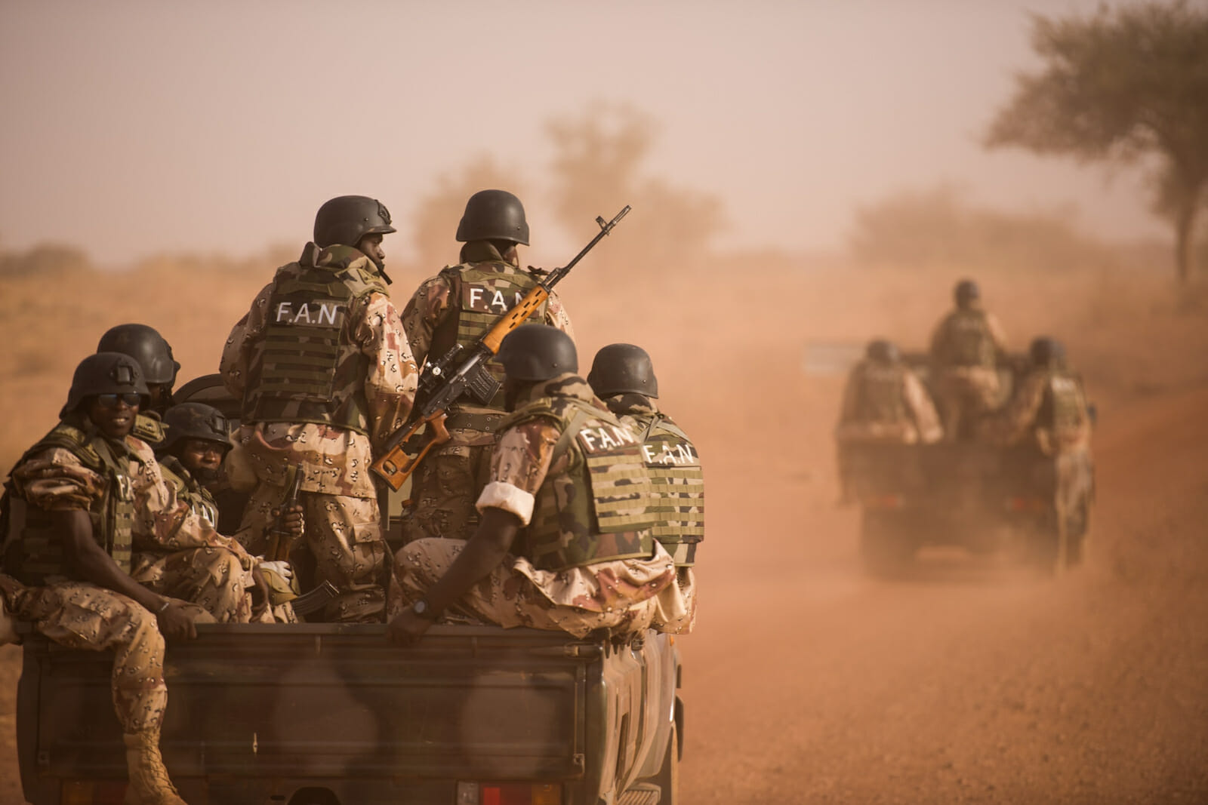
Research Report

Special, Political, and Decolonisation

The Question of Private Military Companies

Background Information
Private military companies, also known as PMCs, are private companies that provide military and security services. They often employ retired military personnel, but may also employ criminals from prisons, amongst others. Traditionally, they offer services such as armed combat, intelligence gathering, and logistical support. However, PMCs have been used by governments and organizations around the world for various purposes, including peacekeeping missions, security for infrastructure projects, and protection of high-profile individuals. Key terms and aspects to address regarding PMCs are mercenaries, security contractors, outsourcing, and rules of engagement. Several major nations play significant roles in the realm of private military companies. These nations include the United States, United Kingdom, Russia, China, and France. However, the involvement of these nations with PMCs varies in terms of regulations, policies, and oversight. Some countries have implemented stricter regulations, while others have a more noninterventionist approach. Perhaps the most well-known PMC is the Russian, state-funded Wagner Group, due to their prominent role in Ukraine, where they have been accused of immense human rights abuses.

Issues
While they can provide valuable services, they face several issues that raise concerns, majorly surrounding their accountability and potential for human rights abuses; they operate outside of traditional military structures and may not be subject to the same regulations and oversight, the lack of transparency making it difficult to hold them accountable for their actions. Another issue is the potential of conflict of interest. PMCs are profit-driven entities, and there is a risk that their financial interests could influence their decision-making. This can lead to questionable practises, such as prioritising profit over well-being of local populations or engaging in activities that may not align with the objectives of the mission or the best interests of the client. Lastly, the reliance on PMCs can raise questions about the role of the state in providing security. Some argue that outsourcing military and security functions to private entities undermines the state’s responsibility to protect its citizens and can erode public trust in government institutions. Addressing these issues requires increased transparency, regulation, and oversight of PMCs. It is crucial to establish clear guidelines, codes of conduct, and mechanisms for monitoring and accountability to ensure that PMCs operate in a manner that upholds human rights, international law, and the best interests of all parties involved.

Countries Involved
USA, UK, Russia, China, France, Ukraine, Sudan, and any country where PMCs operate

Useful Links:
https://ndupress.ndu.edu/Media/News/article/2031922/mercenaries-and-war-understanding-private-armies-today/
https://www.consilium.europa.eu/media/66700/private-military-companies-final-31-august.pdf
https://archive.globalpolicy.org/pmscs/50208-contractor-misconduct-and-abuse.html
https://civiliansinconflict.org/publications/policy/privatizing-war-the-impact-of-private-military-companies-on-the-protection-of-civilians/

