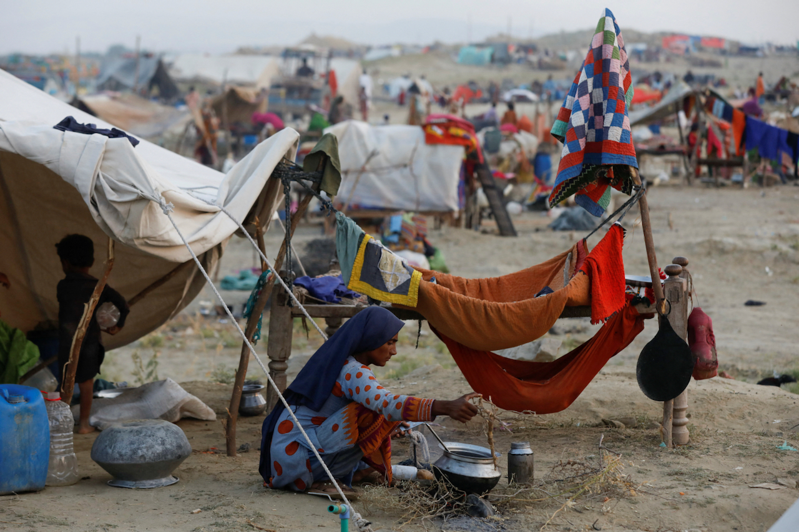
Research Report

Environmental Committee

The Question of Climate Refugees

Background Information
The volume of greenhouse gases emitted into our atmosphere has grown exponentially over the last 150 years, first reaching over 50 billion tonnes annually in 2010. This has resulted in a dramatic increase in the quantity and severity of extreme climate events that have taken place in recent years. This in turn has led to an ever-increasing number of climate refugees, especially after disasters such as flooding or droughts. As outlined in the 1951 Refugee Convention and the 1967 Protocol, refugees have the protected right to seek asylum. It is vital that the international community can find housing for all these displaced peoples, and treatment for them to be fair and equal, no matter the circumstances or characters. The issue of climate refugees stretches across the planet, from Central America to Central Asia. Over 84% of the world’s habitations are in areas significantly affected by climate change, notably through the rising prevalence of extreme weather events and forest fires, as well as the rise of global sea levels. This means that forecasting into the future, the quantity and vulnerability of refugees will only increase. However, as the most vulnerable areas of the world are Afghanistan, West and South-East Africa, and Bangladesh and the Bengal region, extra focus may need to be put on these areas.

Issues
With an increase in the number of displaced people, the question arises as to where to house them, including the extent and quality of such housing. Projects for housing could be started now in accordance with forecasts. Especially when considering there could be a total of around 1.2 billion displaced people globally, it is obvious that something should be done now. Without a place to stay these people will have much more difficult lives, and in less developed areas with not as much access to facilities, this could mean succumbing to disease and illness.

Key Questions
Delegates should be aware the basic human right to seek asylum, and how could relate to this situation.
Delegates could consider the state of their own countries, and whether they have the capability to house refugees, or if they need additional support, perhaps through funding.
Delegates should consider the outcome of these peoples and the world.
Delegates could discuss about putting preventions in place before they become refugees.

Countries Involved
USA, UK, France, Germany, China, Ghana, Mozambique, India, Egypt, and any country that will be subject to the immigration or emigration of climate change refugees.

Useful Links:
""Climate Refugees," Explained"
"The White House Report on the Impact of Climate Change on Migration"
"2021 Global Report on Internal Displacement"
"Economic Recovery after Natural Disasters"
"Environmental Influences on Human Migration in Rural Ecuador"
Key Principles for Policy Making on Migration, Climate Change & the Environmental Degradation

